Kirstin “Frankie” Humason
The Evolution of Medicinal Mushrooms

M is for Mushrooms L is for L- tryptophan

Introduction

The list of the medicinal qualities found in fungi appear to be vast. In this research paper, I would like to focus on and explore the medicinal properties of oyster mushrooms (Pleurotus ostreatus). Oyster mushrooms have been found to contain anticancer, antiviral, and antimicrobial properties (Rogers, R. 2011). How did this come to be? How did some kinds of fungi become considered such a medical asset to humans? I believe these properties are influenced by vitamins, minerals and amino acids contained within Oyster mushrooms.

Due to the magnitude of this subject, this paper will focus on the health benefits associated with amino acids, but more specifically the amino acid L-Tryptophan. I will attempt to create a better understanding of how the amino acid, L-tryptophan, evolved in Oyster mushrooms, and what role it plays in fungi and the human body.

Evolution of fungi

In order to understand how oyster mushroom came to be medicinal, I believe I must first explain the history of fungi and its relationship with humans. There is evidence that Oyster mushrooms possess the ability to heal other animals. For example, there was a study which examined the effects of oyster mushrooms on liver damage in rats. The results were that the rats given oyster mushroom extract had significantly reduced liver damage, when compared to the rats who weren't given the extract (Geraldine et al 2006). However, in this paper I will be mostly focusing on the relationships between humans and fungi. I will do this by going backward through evolutionary time to highlight specific evolutionary markers shared between human and fungi. My hope is that this will bring clarity to why and how health benefits found in Oyster mushrooms affect humans.

Oyster mushrooms are a member of the fungi kingdom, which is the sister species to the animalia kingdom. The plant-animalia-fungi split is estimated to have diverged 1576-88 Ma (Hedges, et al 1999). The evidence of fungi and animals being a sister species was discovered when plant, fungi and animal proteins were compared. Four proteins were exclusively shared between fungi and animals. This gives evidence that fungi shared a closer relation to the animal kingdom than the plant kingdom, contrary to what was previously believed (Baldauf & Palmer 1993).

The date fungi first appeared on Earth's biological timeline is still not clear, but estimates place terrestrial fungi approximately 480-460 mya, according to fossil records. It has been commonly believed that the kingdom of plantae was the first life to become terrestrial, but recent studies are bringing new awareness to the relationship fungi has with the plant kingdom. The new hypothesis is that a type of lichen may have been the first terrestrial life on Earth (Eidell et al 2001). Lichen is a composite organism which is made from a symbiotic relationship between multiple organisms to create one larger organism. Lichen is largely comprised of algae (ancestor fungi) and fungi. The hypothesis of lichen being the first terrestrial when evidence found through a protein sequence analyses which dated been

A new hypothesis has been put forward which suggests fungi may have even been terrestrial before plants, or alongside them. Unfortunately there is limited fossil evidence, as plants and fungi do not preserve easily. However, through a protein sequence analyses, scientists suspect fungi may have been present on land 1000ma, predating land plants first appearance at 700mya (Eidell et al 2001). Fungi possess the ability to break down rock and absorb minerals which would be unobtainable to plant (Agerer et al 1999). This suggests that fungi’s relationship with a photosynthesizing organism may have lead to the first kind of life to colonize Earth. This may have been a composite organism, such as a lichen, made from a symbiotic relationship between multiple organisms to create one larger organism. Lichen is largely comprised of algae (ancestor fungi) and fungi (Eidell et al 2001).

Evolution of L-Tryptophane in fungi

Now I will go on to explain the evolutionary history of L-tryptophan, and how it has come to be relevant to humans.

Through evolutionary history, aromatic amino acids like L-Tryptophan can be traced back to a prebiotic Earth (Joyce, 1989). Aromatic amino acids are directly correlated with the absorption of energy from ultraviolet light (Teale & Weber, 1957). The adaptive process of absorbing light energy would have been extremely useful for survival when Earth conditions provided little resources other than light. For fungi, bacteria and animals, L-tryptophan plays an essential role in synthesising proteins, as well as regulating circadian rhythms and growth hormone (Cole G. T.,1996).

Aromatic amino acids are synthesised through the Shikimate pathway. The Shikimate pathway was lost during the evolution of the animal kingdom. This is thought to be most likely due to the high energetic cost of the biosynthesis of Aromatic amino acids (Last, 1995). Animals were able to obtain sufficient amounts of the amino acid by consuming plants and other organisms, thereby foregoing the high energetic cost of producing it (Faoro, et al 2006). For example: bacteria can spend up to 90% of their total metabolic energy on just protein biosynthesis (Herrmann, 1995).

Plants, bacteria, algae, and fungi posses variations of the Shikimate pathway, enabling the ability to synthesize L-tryptophan. However, the key function of L-Tryptophan differs, in some ways, between these different species. Plants use L-Tryptophan to biosynthesize proteins. It also is used as a stimulatory function to create hormones such as auxin, phytoalexins, glucosinolates, etc. These hormones regulate development, as well as defense response. They also attract pollinators, help detect light, and aid the creation of melatonin to regulate circadian rhythms (Borsarini et al (2003). For fungi, bacteria and animals, L-tryptophan is essential for synthesising proteins and regulating circadian rhythms and growth hormones (Cole, G. T. (1996).

How is L-tryptophan a medicinal property?

L-Tryptophan is an essential precursor for synthesising melatonin and serotonin. Melatonin and serotonin are linked to mood, depression and regulating circadian rhythms. Studies have shown a drop in serotonin levels found in chronically ill patients, especially cancer patients (Capuron et al. 2003). L-tryptophan may indeed have positive effects in countering depression. Depression and stress have been shown to increase DNA damage, which may lead to some types of cancer (Morimoto K. et al 2004). In addition, these factors have an especially negative influence on immune systems that are already dealing with chronic illness such as cancer. I believe that alleviating depression by regulating serotonin levels through L-tryptophan may be a useful tool in fighting off illnesses. There may also be potential for obtaining more adequate sleep by melatonin synthesis through, again, regulating L-tryptophane.

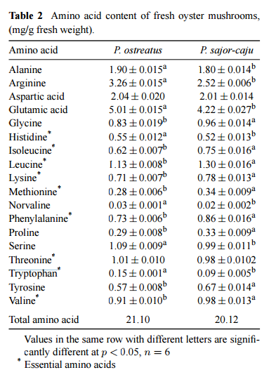
Figure 1. Chart showing the significant values of amino acids found in oyster mushrooms (Chirinang 2009).

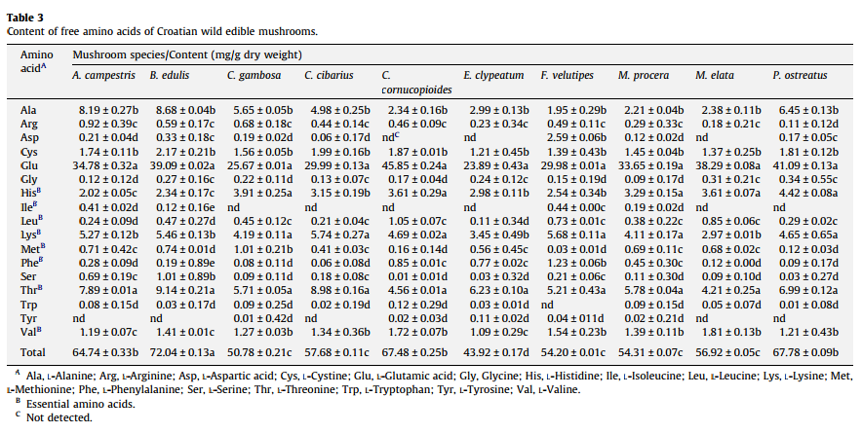
Figure 2. Table showing significant value of L-tryptophan contents in P. ostreatus

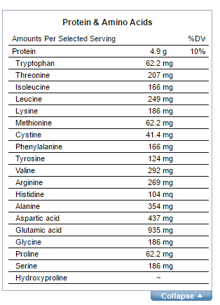
Figure 3. Nutritional contents of 142g of wet P. ostreatus.

As you can see, looking at figure 1 and 2, there are significant amounts of L-Tryptophan and other amino acids in oyster mushrooms. This shows evidence to P. ostreatus containing L-tryptophan.

Figure 3. Gives us a look at the nutritional contents, protein, and amino acid found in P. ostreatus.

The daily recommendation for amino acids has yet to be decided, though World Health Organization suggests 3.5mg per kilogram of weight should be consumed daily. For example, a person that weighs 130 lbs should consume about 206 mg of tryptophane daily. This equals out to be less than one pound of oyster mushrooms. However, for a more practical amount, one meal could consist of ¼ lb of wet oyster mushrooms, which would provide 25% of the recommended daily value of tryptophan.

Conclusion:

The word “medicinal” is used to describe something containing healing properties. I once believed that this signified something separate from basic nutritional needs, such as vitamins and minerals. Today many of our foods have been stripped of their nutritional contents. Some of the underlying reasons behind nutritional stripping stems from a political background, involving the separation of class and race. For example, refined sugar has lost its vitamins and minerals when separated from molasses. This was likely because the color white was considered to be pure and clean, and therefore more suited to be consumed by upper class people. Even the word ‘refined’, meaning polished, stylish or elegant, points to higher class. Many food commodities of today have been shaped through by human history in ways that are political, racial and classist (Tompkins 2012). These changes create nutritional deficiencies, and is why food commodities containing nutritional qualities are so important.

Through my process of researching what role amino acids play in the human body, it has come to my understanding that the true function of the word medicinal is to describe something containing nutrients the body requires to sustain mechanisms already existing within the body. For example: the human body has adapted a mechanism to synthesize serotonin and melatonin. L-tryptophan is required to complete this process. This would mean that an organism containing L-tryptophan could be considered to have medicinal properties.

In the world of evolution there is a theory that altruism is non-existent, and only reciprocal altruism can be found in nature.This is because no organism provides energy and resources to another organism unless it directly benefits itself. Dawkins explains how reciprocal altruism works through a model placed within animal behaviour. This model involves the 'cheat', 'sucker', and 'gudger'. If an organism (the cheat) gains from another organism (the sucker), without giving anything in return, that organism (the sucker) learns to stop giving to the taking organism (the cheat). Thus, the sucker becomes the grudger who no longer gives, and the cheat is at loss (Dawkins 1990). This means that for an organism to want to be eaten, this consumption must be beneficial to the organism itself.

This prompts the question: What about being eaten is beneficial to the oyster mushroom? The most obvious answer is that this spreads spores through an animal's digestive tract. Many edible mushrooms are found next to trails and heavily tracked areas. This is believed to be because mushrooms are trying to be visible and available for eating. Just like seeds found in fruit, the mushroom spores are carried through the animal's digestive tract and spread to new areas via excretion (Stamets 2005).

I do not believe the medicinal properties of oyster mushrooms, however, can be attributed to this evolutionary desire to benefit, and be consumed by, humans and other animals. Simply containing any calories or nutritional value at all could be sufficient enough to attract a pollinator. I think medicinal attributes have more to do with the evolutionary history animals share with fungi. I believe oyster mushrooms contain properties considered to be medicinal to humans because mushrooms share similar nutritional needs.

Humans and animals share an evolutionary history with fungi. Through that shared history, we share similar nutritional and health needs. The medicinal qualities found in oyster mushrooms, such as tryptophan, could definite possess healing properties for humans. The original formation of these healing properties may date back to the very origins of life, and the building blocks of our diverse, present-day life forms.

Citations:
Agerer, R., Kraigher, H. Trost, T., & Urbancic, M., (1999). Biodiversity of ectomycorrhizae in a Norway spruce stand on Pokljuka. PHYTON-HORN-, 39, 225-232.

Radwanski, E. R., & Last, R. L. (1995). Tryptophan biosynthesis and metabolism: biochemical and molecular genetics. The Plant Cell, 7(7), 921–934. Retrieved from http://www.ncbi.nlm.nih.gov/pmc/articles/PMC160888/
Iriti, M., Rossoni, M., & Faoro, F. (2006). Melatonin content in grape: myth or panacea? Journal of the Science of Food and Agriculture, 86(10), 1432–1438. https://doi.org/10.1002/jsfa.2537
Heckman, D. S., Geiser, D. M., Eidell, B. R., Stauffer, R. L., Kardos, N. L., & Hedges, S. B. (2001). Molecular Evidence for the Early Colonization of Land by Fungi and Plants. Science, 293(5532), 1129–1133. https://doi.org/10.1126/science.1061457
Stamets, P. (2005). Mycelium Running: How Mushrooms Can Help Save the World. Ten Speed Press.
Baldauf, S. L., & Palmer, J. D. (1993). Animals and fungi are each other’s closest relatives: congruent evidence from multiple proteins. Proceedings of the National Academy of Sciences, 90(24), 11558–11562. Retrieved from http://www.pnas.org/content/90/24/11558
Beluhan, S., & Ranogajec, A. (2011). Chemical composition and non-volatile components of Croatian wild edible mushrooms. Food Chemistry, 124(3), 1076–1082. https://doi.org/10.1016/j.foodchem.2010.07.081
Wang, D. Y.-C., Kumar, S., & Hedges, S. B. (1999). Divergence time estimates for the early history of animal phyla and the origin of plants, animals and fungi. Proceedings of the Royal Society of London B: Biological Sciences, 266(1415), 163–171. https://doi.org/10.1098/rspb.1999.0617
Cole, G. T. (1996). Basic Biology of Fungi. In S. Baron (Ed.), Medical Microbiology (4th ed.). Galveston (TX): University of Texas Medical Branch at Galveston. Retrieved from http://www.ncbi.nlm.nih.gov/books/NBK8099/
Rogers, R. (2011). The Fungal Pharmacy: The Complete Guide to Medicinal Mushrooms and Lichens of North America. North Atlantic Books.
Capuron, L., Neurauter, G., Musselman, D. L., Lawson, D. H., Nemeroff, C. B., Fuchs, D., & Miller, A. H. (2003). Interferon-alpha–induced changes in tryptophan metabolism: relationship to depression and paroxetine treatment. Biological Psychiatry, 54(9), 906–914. https://doi.org/10.1016/S0006-3223(03)00173-2
Reiche, E. M. V., Nunes, S. O. V., & Morimoto, H. K. (2004). Stress, depression, the immune system, and cancer. The Lancet Oncology, 5(10), 617–625. https://doi.org/10.1016/S1470-2045(04)01597-9
Caniato, R., Filippini, R., Piovan, A., Puricelli, L., Borsarini, A., & Cappelletti, E. M. (2003). Melatonin in Plants. In G. Allegri, C. V. L. Costa, E. Ragazzi, H. Steinhart, & L. Varesio (Eds.), Developments in Tryptophan and Serotonin Metabolism (pp. 593–597). Springer US. Retrieved from http://link.springer.com/chapter/10.1007/978-1-4615-0135-0_68
Herrmann, K. (1995). The Shikimate Pathway: Early Steps in the Biosynthesis of Aromatic Compounds. The Plant Cell, 7(7), 907–919. Retrieved from http://www.ncbi.nlm.nih.gov/pmc/articles/PMC160886/
Bano, Z., Srinivasan, K. S., & Srivastava, H. C. (1963). Amino Acid Composition of the Protein from a Mushroom (Pleurotus sp.). Applied Microbiology, 11(3), 184–187. Retrieved from http://aem.asm.org/content/11/3/184
Jayakumar, T., Ramesh, E., & Geraldine, P. (2006). Antioxidant activity of the oyster mushroom, Pleurotus ostreatus, on CCl4-induced liver injury in rats. Food and Chemical Toxicology, 44(12), 1989–1996. https://doi.org/10.1016/j.fct.2006.06.025
Pasek, M. A., & Lauretta, D. S. (2005). Aqueous Corrosion of Phosphide Minerals from Iron Meteorites: A Highly Reactive Source of Prebiotic Phosphorus on the Surface of the Early Earth. Astrobiology, 5(4), 515–535. https://doi.org/10.1089/ast.2005.5.515
Dawkins, R. (1990). The Selfish Gene (2 edition). Oxford ; New York: Oxford University Press.

