Translating Transmissions:
Reading the Swarm, Recycling the Mess
Mary Kallem
Mary 30, 2013
As Poetry Recycles Neurons
Term Paper

Abstract
While echoing the structure of Susan Howe’s The Midnight, this paper contains two sections of lyric essays, two sections of/on poetics, and one of linguistic ellipses. In these, the author interrogates themes of generative poetry, swarm intelligence, and sense-making. Two possible frameworks for assigning meaning to objects—material and theoretical—are supplied: Philip K. Dick’s classification of “kipple” and Ian Bogost’s Latour Litanies. Within each paradigm, parts are combined to produce two vastly different wholes. Applying each framework to the craft of generative poetry, the author explores what happens poetically when these parts are entrusted with agency. This is done so through genetic algorithms and NetLogo, an agent-based modeling environment.

if text ! = poetics [
consider BED-HANGINGS
assume neither [ human nor machine ]
[ comfort nor abandonment ]
heed input “Precipitation: violent passages: from which we each emerge: rending: stuffed: awkwardly shaped by the heat of such and such a system.”
–Caroline Bergvall, “Fourth Tableau”
]
end
--------------

A jGnoetry combination of the first page of Susan Howe’s The Midnight, Wallace Stevens “Anecdote of the Jar”, and the 20 most frequently used words from the introduction of Deleuze and Guattari’s A Thousand Plateaus:

“Stage and rhizome and
Tall form illustration
Paper book multiplicity
Root to it
Round one slovenly world proposed.
It represents in root tree ground interleaf
Map the thing wild of sentence every
The thing or bush, multiplicity.”

Translation:
“Stages and rhizome and
Illustrations revealing depth.
Printed words, a multiplicity:
Root
‘Round this one slovenly, proposed world,
Represented in root, tree, ground, interleaf,
Mapping the wild thing of every sentence.
The Thing or Tennessee: multiplicity.”

EVENT
“Deft hedgerows, deft spectacular sister,
Compel deft beginning sister.
Punishment, evacuate punishment sister, deft pleasure.
Crying, crowding, deft station, punishment snows pleasure deft.”

A: Station
B: Ample
C: Robes
D: Compel
E: Deft
F: Beginning
G: Posture
H: Tongue
I: Evacuate
J: Included
K: Sweat
L: Crowding
M: Tend
N: Spectacular
O: Composed
P: Crying
Q: Kids
R: Pleasure
S: Punishment
T: Sister
U: Snows
V: Hedgerows
W: Lesson
X: Following
Y: Middle-aged
Z: Grammar

We once said:
The thing itself deceives the name we give it.
Now we say:
There is no-thing to begin with. Just sign and surplus.

ORDER,
REGARDLESS
OF
ORIGIN,
STILL
PRODUCES
TEARS.

Rhizomatic structures lead to infinite reconfigurations of a resilient body.



if text ! = prose [
consider SCARE-QUOTES
heed query “Is it possible to write what is happening?”
-Amy Catanzano, “Quantum Poetics, Writing the Speed of Light”
]
end
--------------

In Do Android Dream of Electric Sheep, Philip K Dick writes about a classification of objects termed “kipple.” These are objects that have lost their utility since production, now serving as permanent, obsolescent clutter. These are old receipts, half-empty condiment jars, plastic bags holding crumbs, and replacement screws for lost toys.
Kipple is homogenous: impossible to differentiate from itself, there is no singular unit of kipple.
Kipple is always in the way: like a fever dream of late capitalism, it tumbles from our backpack pockets, car doors, and the in-betweens of sofa cushions.
Kipple is unoriginal: kipple’s origin is within other kipple. Kipple is contagious and reproduces wildly—it multiplies like a cancer that no radiation will kill.
Kipple is a materialization of entropy, and as such, “it’s a universal principle operating throughout the universe; the entire universe is moving toward a final state of total, absolute kippleization” (Dick, 66).
This classification of junk offers itself easily to anti-consumerist readings, railing against planned obsolescence and materialistic desires. However, this phenomena is also laden with troublesome implications as to how value is created and located within objects. In a Dickian universe, meaning slips so quickly away from its anchoring objects. Utility is the singular cord tethering value to object, signified to signifier. This system leaves no room for repurposing or rewriting. Through condemning old objects—and by extension, ideas—as uselessly used-up, this system refutes authorship. This system allows only for the wholly new: an impossible, insatiable demand. Must we abandon the agency of a tinkerer? Perhaps our cultural territories are Wastelands, but there is much to salvage from them yet.

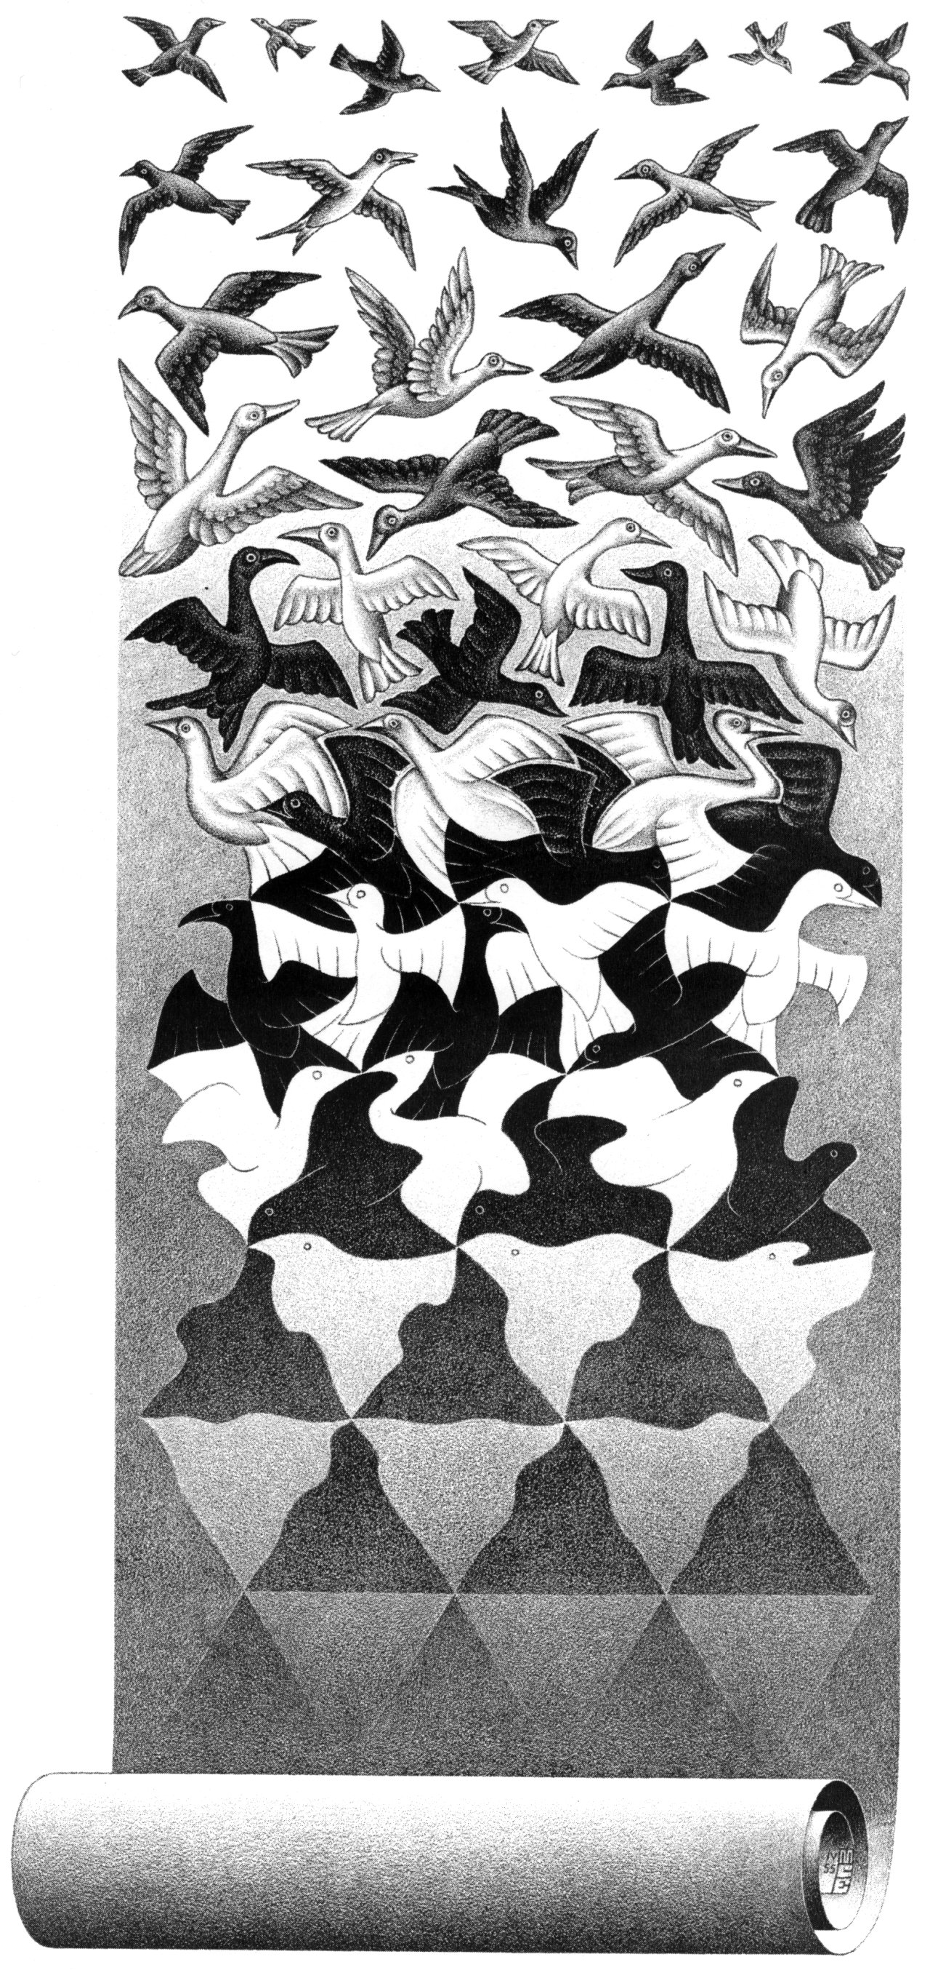

“I … simply repeated to myself “Nothing can be reduced to anything else, nothing can be deduced from anything else, everything may be allied to everything else.” This was like an exorcism that defeated demons one by one. It was a wintry sky, and a very blue. I no longer needed to prop it up with a cosmology, put it in a picture, render it in writing, measure it in a meteorological article, or place it on a Titan to prevent it falling on my head. […] It and me, them and us, we mutually defined ourselves. And for the first time in my life, I saw things unreduced and set free.” -Bruno Latour, “Irreductions”

In response to the above excerpt, media philosopher Ian Bogost created a poetic device entitled the Latour litany. These litanies aim to capture the irreducibility of vast expanses of stuff, offering a counterpart to the Dickian Oneness of kipple.
An example of this form can be found within Richard Rhodes description of 1945 Hiroshima bombing’s aftermath:
“Destroyed, that is, were not only men, women and thousands of children but also restaurants and inns, laundries, theater groups, sports clubs, sewing clubs, boys’ clubs, girls’ clubs, love affairs, trees and gardens, grass, gates, gravestones, temples and shrines, family heirlooms, radios, classmates, books, courts of law, clothes, pets, groceries and markets, telephones, personal letters, automobiles, bicycles, horses—120 war-horses—musical instruments, medicines and medical equipment, life savings, eyeglasses, city records, sidewalks, family scrapbooks, monuments, engagements, marriages, employees, clocks and watches, public transportation, street signs, parents, works of art.” (733)

This technique departs from Jorge Luis Borges’ “Chinese encyclopedia” entries as they make no claims of collection: these are not categories of tamed objects. There is no illusion of control, and the authorial process of naming is recognized as subjective and unstable. What follows are merely things to notice. The litanizer is placed within a landscape of hills, Tennessee is but one of many potential states, and there are thousands of jars.
A primary objective of science is to provide meaning through systematic naming processes. Illustrated by animal taxonomies, science simplifies the complexities of the world by associating similar bodies together: one zebra is interchangeable with any other zebra. Latour’s thinking frees us from this collapse of diversity, instead allowing each body to be defined through agent-specific relations. What we call a zebra becomes less important than the zebra’s relationship to her foal.
Depending on the tightness and automaticity of ones’ sense-making mechanisms, boundless expanses of stuff can be regarded as kipple or as a Latourian litany. There are many similarities between these modes of classification: both models recognize definition as being defined through relations. Kipple is a status balanced on assessments of utility, while Litanies on mutuality. Additionally, both are disloyal to anthrocentric narratives of ontology and taxonomy; in each model, “things” refute naming processes. Receipts refuse to stay receipts, instead degenerating into the kipple-matrix. For Latour, no thing is exclusively what we name it.
It is only when we amputate and transfer examples from one model to the other do we begin to recognize critical differences. When we apply Dick’s process of kippleization to a pack of zebras, our associations of noble wildness get stripped away. We are left with an undifferentiated hoard. Culture is unable to locate value within an other species and zebras resist a utilitarian reading. For this culture, zebras are simply not useful.
Secondly, it’s possible to cobble together a Latour litany from the debris of post-industry—indeed, the literary canon of cyberpunk is based upon this trope. Receipts are not doomed to shift into parasitism, but may instead be regarded as discrete objects capable of reevaluation. They may be reprogrammed as a resource or collectible: they may gain epistemological significance through a reconsideration of relationship. We allow new meaning to be produced by old objects. We are enfranchised as authors, alchemically turning junk to genius.

“A book is more than a verbal structure or series of verbal structures; it is the dialogue it establishes with its reader and the intonation it imposes upon his voice and the changing and durable images it leaves in his memory. A book is not an isolated being: it is a relationship, an axis of innumerable relationships.” -Jorge Luis Borges, "A Note on (toward) Bernard Shaw"

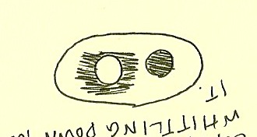
Is meaning rooted inside, outside, or in between?

if text ! = poetics [
consider BED-HANGINGS
assume neither [ human nor machine ]
[ comfort nor abandonment ]
heed input “Precipitation: violent passages: from which we each emerge: rending: stuffed: awkwardly shaped by the heat of such and such a system.”
–Caroline Bergvall, “Fourth Tableau”
]
end
--------------

patches-own [
letter-array ]

to setup
clear-all
set-default-shape turtles "bug"
;; randomly distribute wood chips
ask patches
[ if random-float 100 < density
[ set pcolor yellow ]
]
;; randomly distribute termites
create-turtles number [
set color white
setxy random-xcor random-ycor
set size 2 ;; easier to see
]
end

to go ;; turtle procedure
search-for-chip
find-new-pile
put-down-chip
end

to search-for-chip ;; turtle procedure -- "picks up chip" by turning orange
ifelse pcolor = yellow
[ set pcolor black
set color orange
fd 20 ]
[ wiggle
search-for-chip ]
end

to find-new-pile ;; turtle procedure -- look for yellow patches
if pcolor != yellow
[ wiggle
find-new-pile ]
end

to put-down-chip ;; turtle procedure -- finds empty spot & drops chip
ifelse pcolor = black
[ set pcolor yellow
set color white
get-away ]
[ rt random 360
fd 1
put-down-chip ]
end

to get-away ;; turtle procedure -- escape from yellow piles
rt random 360
fd 20
if pcolor != black
[ get-away ]
end

to wiggle ; turtle procedure
fd 1
rt random 50
lt random 50
end

to get-letter-array
ask patches [
if pcolor = yellow [set letter-array random 200
file-open "letter-array-chart.csv"
file-write "letter-array is"
file-write letter-array
file-close] ]

end

Much credit goes to Uri Wilensky for writing the original code on which I expanded; this code can be found in the NetLogo Model Library as “Termites.”

The above code was specifically developed for NetLogo, a modeling environment equipped with its own agent-based programming language. In layman’s terms, NetLogo is a computer program that runs spatial and temporal simulations, as provided by code. These simulations include “agents,” which are units that act and interact as directed—NetLogo refers to agents as “turtles.” These turtles manipulate objects, termed “patches,” that are placed within their landscape. This program is used to visualize competing population fluctuations, traffic patterns, and the spread of disease. Because it’s a modeling environment, this program provides numeric and graphical data, allowing changes to be seen over time and within space.
For my project, I knew I wanted to harness genetic algorithms to create a generative poetry machine. I had originally intended to use the Artificial Bee Colony algorithm as a basis, but found NetLogo’s pre-programmed, easily manipulated termite code to serve just as well. Also classified as swarm technology, this code seeks to learn something from “natural” termite wood-chip gathering patterns that can then be applied to very un-termite-like endeavors—such as visualizing the basis of primitive accumulation.
When I began studying swarm technology, I found myself mesmerized by its failures: its irreverence to its objects of study, the ways in which internal pattern-making structures are mapped over and lost in translation. Through repurposing the means of a swarm, technology had failed to communicate the qualia of swarming.
Swarm is both noun and verb. These algorithms, used to maximize efficiency while transporting crude oil and developing call-centers, had lost sense of where subject and action intersect. What was lost was agency: the delicate balance between self and swarm. Lost was an understanding of maintaining two bodies: the body of flesh and the body politic. The sheer utility of decentralized structures was being valued more than the alternate sense of embodiment it provided.
When NetLogo is referred to as an “agent-based” modeling environment, it stinks of irony. There is no semblance of agency rooted in this coding, no freedom to be found in commands of “wiggling.” In my lexicon, agents do not wiggle—agents kill people. Agents act powerfully.
Perhaps it was counterintuitive to begin searching for this lost agency on such a hollow front, but that was exactly where it felt most needed. To read technology through untraditional means is to recode it: when confronting text with new values, text responds with new meaning. I assured myself that if I listened close enough, I would be able to hear hushed whisperings of a code ignored. What would happen if I attempted to delicately translate these internal pattern-making structures, as opposed to mapping over them?
Just as Craig Holdrege asserted, I needed to be in dialogue with my specimen. In order to do so, it was necessary to speak first. By altering code, I provided a voice box for the termites: in my model, each pile of wood represents one poem, and each woodchip a word. When placed in a pile, the woodchip randomly generates a number corresponding to a specified word: for instance, 83 translates to “laboratory.” This coding change meant mapping the English language onto (but not over) the patterns provided by the termites sorting wood.
The animalistic turned biological turned computational now turned poetic. This project recognizes that although much is lost in translation, each “new” rhetoric provides a site of hermeneutic fecundity. Meaning does not end at the bounds of authorial intention—it is up to the reader to extend. Secretly, my project aims to bastardize and debase: I am not interested in worshipping the sanctity of institutionalized science. Instead, I’d like to steal their tools for my own means. I can write meaning, too.

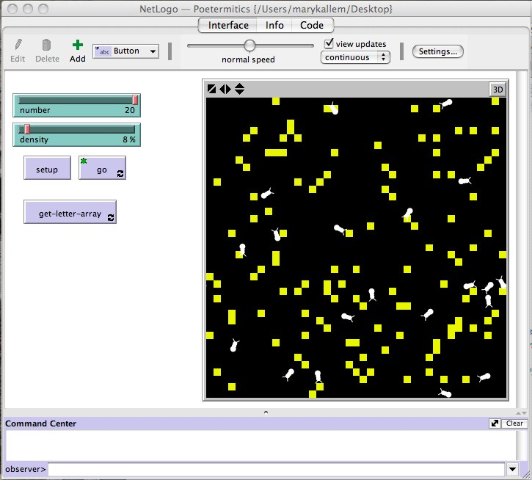
Figure 1: Code at set up. Square wood chips and termites have been randomly dispersed.
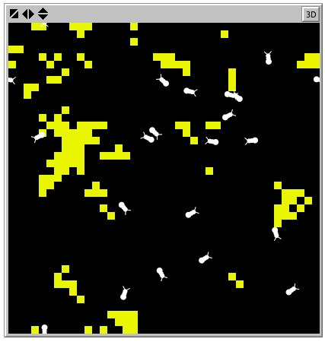
Figure 2: As the model runs, the termites begin to cluster woodchips together, assigning them randomized number arrays
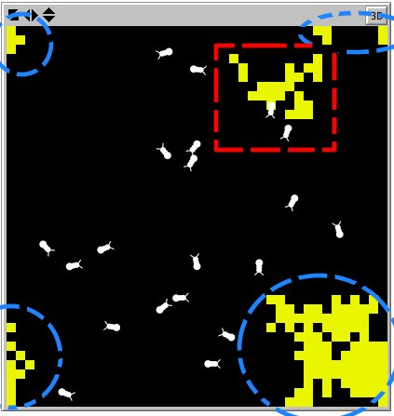
Figure 3: Two piles have been formed, which I've outlined in circles and squares. Keep in mind the graph’s toroidal axes.

if text ! = prose [
consider SCARE-QUOTES
heed query “Is it possible to write what is happening?”
-Amy Catanzano, “Quantum Poetics, Writing the Speed of Light”
]
end
--------------
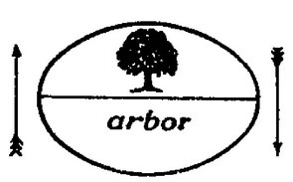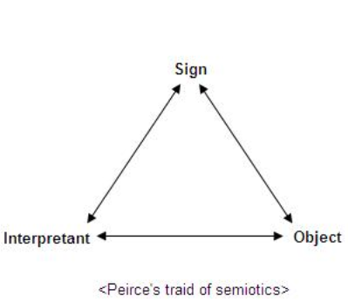
1, 2, 3

After a lifetime of miscommunication, two years of peer tutoring hundreds of unintelligible student papers, and months dedicated to peripherally studying semiotics, the great distance between writer and reader, speaker and listener, brain and brain became pressingly obvious. Although I’d like to praise language as an organ of mutuality, I deeply believe that language frequently serves as a tool of estrangement. Language brings to light how much can be lost in the space between two bodies—what one individual means and another individual understands never stands as a 1:1 ratio.
"It only means that there will be a new form; and that this form will be of such a type that it admits the chaos and does not try to say that the chaos is really something else. The form and the chaos remain separate. The latter is not reduced to the former. That is why the form itself becomes a preoccupation, because it exists as a problem separate from the material it accommodates. To find a form that accommodates the mess, that is the task of the artist now."
–Samuel Beckett, “Beckett at the Madeleine”

I became drawn to generative poetry because of how it complicates sense-making processes. When I say “generative poetry,” I am referring to texts created through procedural means, such as word-selecting algorithms. Despite these texts adhering to very specific compositional rules, their meanings are arbitrary: content is ultimately ruled by form. Treating language as data, this method of writing uses words not as airy, sacred signifiers, but instead as opaque building blocks. Through imposing new systems of order, the author (or mechanic, technician, or programmer) disregards hermeneutic convention and displaces illusions of transcendental signification.
From the readers’ perspective, this can frequently seem like babble. jGnoetry, the online poetry machine, uses a randomization process ultimately constrained by syllabic parameters. For a reader informed of the text’s history, it reads as nonsense. Yet, babble does not remain babble for long. We, users of language, have the capacity to read meaning into just about anything—that is, if we want to. In Strangers to Ourselves, Timothy Wilson asserts that we engage in “confabulation,” on a daily basis. This is the process of creating explanations for otherwise inexplicable correlations, allowing us to render the world intelligible. Confabulation is how meaning is made, granting us certainty in an uncertain world.
---------
In order to grant products of jGnoetry meaning, simply withhold the poem’s origin story from the reader. They will assume it is avant-garde experimental writing, perhaps drawing from Gertrude Stein’s Tender Buttons. Depending on if you input Tender Buttons as the source text to be scrambled, they will be absolutely correct.
---------
Generative poetry relies upon meaning being relationally defined: meaning only occurs when symbols are placed in a field of other symbols. Through systematic rearranging, programmers unlock the fecundity of signification.

“In this ideal text, the networks are many and interact, without any one of them being able to surpass the rest; this text is a galaxy of signifiers, not a structure of signifieds; it has no beginning; it is reversible; we gain access to it by several entrances, none of which can be authoritatively declared to be the main one.”
–Barthes, S/Z

The Internet is a collage, where everything is capable of a repurposing. It is a bastardization of all it contains: in such an intricately laced network, there is no primary order capable of superseding any other. Text leads to text leads to text, in a hyper-navigable landscape of disembodied data. Yet, it is precisely this agency that leads to a reduction of epistemic weight. Despite exemption from the principles of scarcity, the Internet remains victim to the rules of capitalism—increased access leads to decreased value. But it is this decreased value that enfranchises so many individuals’ participation within it: the authorial voice is suddenly granted to the masses. Will this cultivate an irreducible heteroglossia or a landscape of e-kipple? That depends on who reads it.

if text ! = incomplete [
consider KIDNAPPED
heed input “To make a prairie it takes a clover and one bee,
One clover and a bee,
And revery.
The revery alone will do,
If bees are few.” -Emily Dickinson, Complete Poems

I didn’t succeed. It didn’t work. Well, not yet. I’d probably need a few more weeks and Excel wizard to get me to where a reader would like me to be.
I spent hours digging through As Poetry Recycles Neurons’ class readings, inputting every word I had jotted in the gutters or underlined from within the text. There we even some pictures. Each of these units—particles, textons, woodchips—were placed in a spreadsheet according to chronology. This process assigned each unit a number, corresponding to the numbers generated by my NetLogo program.
Essentially, this leaved me with two 6,000 cell spreadsheets, one a list of numbers and the other a master list of marginalia. They correspond to each other in theory, but not in programming; I still need to make them connect to one another. Otherwise, I’d have to do it manually. Besides being grueling task, it would also undermine the advice given to me by every programmer I’ve spoken to during the course of this project: Computers are supposed to make your life easier. They do the things that we don’t want to.
I’ll keep working on my program, and hopefully there will be different text in this section a few weeks from now. Instead there will be whispering of the swarm, the recycling of the recycled. Old turned new, an assemblage of scavenged text with rearrangement as sutures.

Anecdote of the Jar by Wallace Stevens “I placed a jar in Tennessee, And round it was, upon a hill. It made the slovenly wilderness Surround that hill. The wilderness rose up to it, And sprawled around, no longer wild. The jar was round upon the ground And tall and of a port in air. It took dominion every where. The jar was gray and bare. It did not give of bird or bush, Like nothing else in Tennessee.”
It’s worth mentioning that, unlike receipts, we do not actively produce zebras. Yet, we still produce a taxonomic category of zebra, thus rendering objects from bodies and relations.

