TESC Solar Covered Parking Overview
Jimmy Hadley
5 Aug 2015

Installing a 100kW system of solar canopies in B and C lot would cover the parking stalls with the highest yearly sunlight exposure. The 9 parking stall islands would be completely covered, providing relief from heat and train throughout the year.

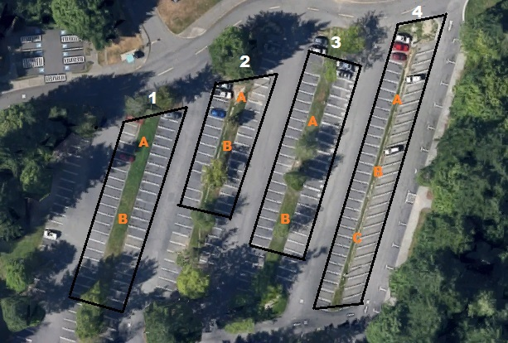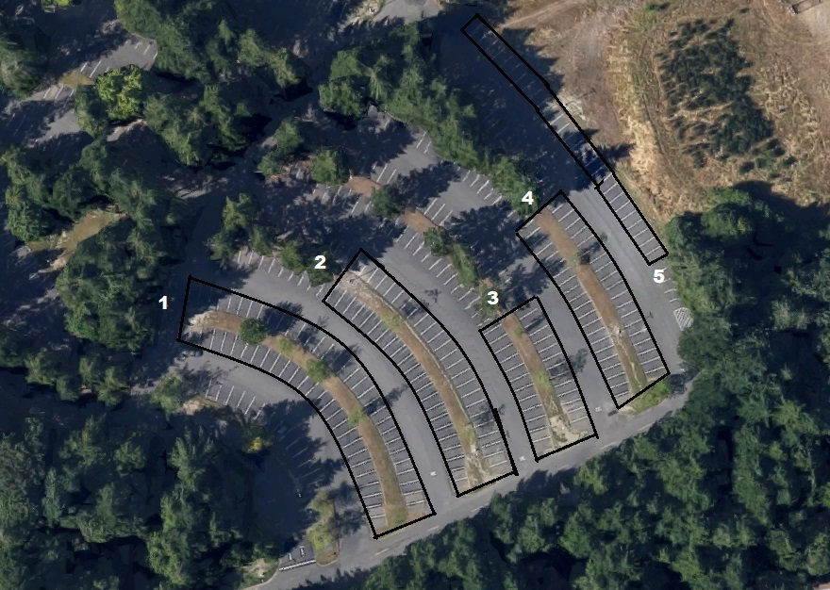
Fig 1 North side of B Lot South side of C Lot

The installation will involve building the support structure for the covered stalls, evaluating the existing electric infrastructure, purchasing up to 5000 panels measuring 1x1.5m each, and setting up an ongoing maintenance program. We have found estimates of $3-5 per watt installed; this has an upward cost of $500,000 for the support structure, panels, inverters, electric infrastructure, and legal permits.

The solar panel supplier will be chosen locally to reduce the carbon footprint of the purchase. We have found suppliers in Oregon, California, Colorado, and Washington State that are highly ranked in quality and sustainability based on material sourcing, materials used, lifetime, recyclability, and human health impact.

100 kW of solar provides approximately 100,000 kWh of power per year. This will save TESC approximately $8000 per year in power and green tag costs. Over a 30 year lifespan, this will prevent 1,600 tons of coal from being consumed and keep 4700 tons of CO₂ from being released into the atmosphere.

These costs and returns are rough estimates; there are options for improving these by:
- Bulk rate on solar panel purchase
- Hire a solar installation company
- Grants and funding programs may cover most of the costs

Once this project is successfully completed, TESC will have more experience and connections to help expand its renewable energy program.
Sources:

http://www.google.com/url?q=http%3A%2F%2Fwww.solarscorecard.com%2F2014%2F2014-scorecard.php&sa=D&sntz=1&usg=AFQjCNHvj0mbJSk1W0LGdm8msBYQCLfBCA

http://www.eia.gov/tools/faqs/faq.cfm?id=667&t=2

http://www.eia.gov/coal/production/quarterly/co2_article/co2.html

http://solairegeneration.com/

http://www.nrel.gov/docs/fy13osti/56776.pdf

Based on a quote from Solaire Generation and a report by the DOE.
100 kW x 1000 hours of sunlight per year.
1 ton of coal provides 1900 kWh
CO₂ has an atomic weight of 44. Based on the ratio of 1 lb of carbon combines with 2.67 lbs of oxygen, totalling 3.67 lbs of CO₂. 1 ton of coal at a 78% carbon content will produce 2.86 tons of CO₂.

