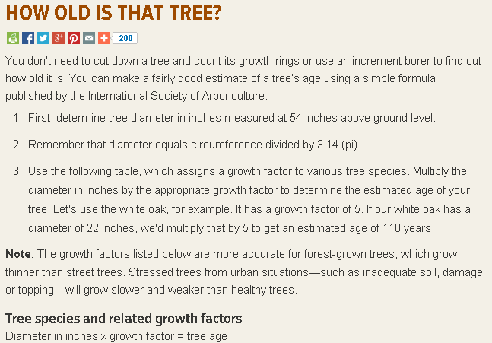
http://mdc.mo.gov/your-property/your-trees-and-woods/backyard-tree-care/how-old-tree

Growth According to Age
http://www.na.fs.fed.us/pubs/silvics_manual/Volume_1/pseudotsuga/menziesii.htm

