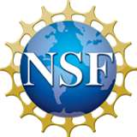
Fall Series 2012
CAMEL Climate Change Continuing Education Symposium
Webinar Registration & Archive
Each presenter discusses a teaching resource and how to use it. The resources are designed for upper level education, but some may be modified for other levels or incorporated into hybrid teaching. The resources are found on the CAMEL (Climate Adaptation and Mitigation E-learning) site.
CAMELclimatechange.org

Webinars held Oct. 2 – Dec. 4, 2012 – ONE REMAINING
Webinar 1 –  Oct. 2  Climate Change Education:  Integrative, Innovative, Online |  | Arnold Bloom  Plant Sciences,  University of California, Davis | Ended  See recording
Webinar 2 –  Oct. 9  Climate Change in Rural Nevada:  Multimethod research regarding indigenous people and their rancher neighbors | 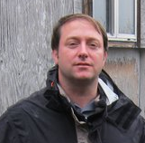 | William (Bill) Smith  Harry Reid Center for Environmental Studies, UNLV; Anthropology,  NSF-funded Native Americans and Climate Change video | Ended  See recording
Webinar 3 –  Oct. 16  Responding to the Challenge of Climate Change |  | Elizabeth Davey, Director,  Environmental Affairs, Tulane University | Ended  See recording
Webinar 4 –  Oct. 23  "Gaming Dos and Don'ts: Lessons Learned from Inside and Outside the Classroom." | 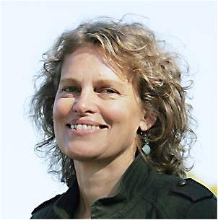 | Stephanie Pfirman  & Patrick Callahan  Barnard College | Ended  See recording
Webinar 5 –  Oct. 30  Climate Change Geoengineering |  | Wil Burns,  Associate Director  Master of Science, Energy Policy & Climate Program Johns Hopkins University | Rescheduled – Nov. 20 – due to Hurricane Sandy
Webinar 6 –  Nov. 13  Climate Change, Energy, and Nuclear Power |  | John Perkins,  Senior Fellow NCSE,  Professor Emeritus, Evergreen College | Ended  See recording
Webinar 7 -  Nov. 20  Climate Change Geoengineering |  | Wil Burns,  Associate Director  Master of Science, Energy Policy & Climate Program Johns Hopkins University | Ended  See recording
Webinar 8 –  Nov. 27  Supporting Educators: Teaching Tools from the Climate Literacy and Energy Awareness Network and a summary of the review process. |  | CLEAN (Climate Literacy Energy Awareness Network) | Ended  See recording
Webinar 9 –  Dec. 4  How Success Works: Using case studies to teach systems thinking as a way to approach eco-social problems related to climate change. | 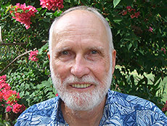 | Gerry Marten & Deidre Duffy, EcoTipping Points   . | ACTIVE  Register here
