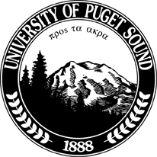
SLUDGE
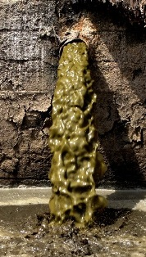
WHAT'S IN YOUR COMPOST?
WHAT'S IN OUR FOREST AND AGRICULTURE SOILS?
March 25, 2013 6:30 – 8:30 PM
Murray Board Room, Wheelock Center University of Puget Sound
1500 N Warner St, Tacoma WA 98416

Darlene Schanfald, PhD Campaign Organizer, Sludge Free WA Sierra Club WA State Chapter
Richard Honour, PhD Plant Pathology and Soil Microbiology Scientific emphasis in infectious diseases and soil microbiology
Executive Director of The Precautionary Group in Kenmore, WA, a Washington State nonprofit corporation established to evaluate the adverse effects of land-applied sewage sludge and other toxic wastes used as composts, fertilizers, and soil amendments.
Documentary: Sludge Diet
Learn about sludge as they wind their way from production to product, where they are applied, and the results of their application.
Many composts/fertilizers contain toxic materials from municipal wastewater treatment plants, industry, or large animal feed lots in the form of sludge. Sludge contains a complex mixture of organic and inorganic chemicals and pathogens, pesticides, radionuclides and other environmentally persistent and bio accumulative poisons. These can be carcinogenic, hormone disruptive and neurotoxic.
These composts/fertilizers are sold as soil amendments to farms, marketed for residential gardens, and spread on forestlands.
Sludge Diet will be shown in the first hour, followed by Dr. Honour's presentation on the consequences of spreading toxic sludge on forestlands.

Hosted by the Pierce County Group of the Sierra Club and University of Puget Sound’s Sound Policy Institute

