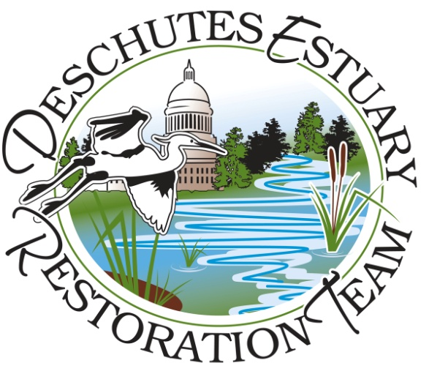
Deschutes Estuary Restoration Team
Volunteer Coordinator Job Description
June 17, 2013

Volunteer Program Overview:
DERT is developing an active “Imagine the Deschutes Estuary “ volunteer program that will recruit, train and deploy marine ecosystem advocates and redesign the current misinformation being touted by non-estuary supporters. We are seeking a volunteer coordinator who will, with assistance from DERT staff and board members, develop recruit and train up to one hundred (100) new and enthusiastic messengers. The volunteer coordinator will also convene a group of published and engaged scientists and technical experts to help prepare training materials.
Target volunteer groups for our program will be downtown business owners and employees, youth Earth Corps, veterans and the public. Outputs and outcomes will focus on numbers of volunteers recruited, number and impact of contacts with our larger public audience, an “Imagine the Deschutes Estuary” campaign resulting in an increase in estuary restoration support.
General Qualifications:
The Volunteer Coordinator will have the following skills and expertise:
- At least two years of higher education in the form of an Associate Degree and/or a Bachelors Degree with a focus on environmental science and/or policy.
- Demonstrated ability to:
  - Communicate with, supervise and empower volunteers to be effective in their roles – experience with volunteers preferred.
  - Work cooperatively with different types of personalities, age groups and economically diverse populations.
  - Work under the supervision of the Executive Director and the oversight of the DERT Board.
- Knowledge and understanding of issues and dynamics that can be present when promoting environmental projects including a thorough understanding of the interaction between the environment and the economy.
- Commitment to DERT’s mission and strategic priorities.
Duties:
DERT’s Volunteer Coordinator will recruit volunteers from the community and match their skills with Volunteer Program needs. The Volunteer Program will be developed by the Coordinator with help from the Executive Director and the Education and Outreach Committee. The new Volunteer Coordinator will
- Educate the public on the benefits of restoring the Deschutes Estuary.
- Establish the volunteer program and recruit enthusiastic volunteers.
- Serve as the first point of contact for DERT volunteers and maintain communications.
- Research and develop opportunities for volunteers.
- Work with the Education and Outreach Committee and the DERT Strategic Priorities to align education and advocacy needs with volunteer skills and expertise.
- Work with Executive Director to develop training for volunteers.
- Contribute to the DERT newsletter.
- Keep an ongoing record of volunteers, opportunities, program activities, outcomes and products.
- Develop positive and professional relationships with other organizations.
- Provide office coverage as assigned by the Executive Director.
- Help plan the annual DERT picnic to recognize the efforts of our volunteers.
- Report back to the Executive Director and the Board of Directors at monthly board meetings.
Compensation:
The Volunteer Coordinator will be hired under a contract and work approximately 20 hours a week. Contract timeframe will initially be for one year but DERT is committed to finding funding to keep this position going. The Coordinator will be responsible for all taxes, insurance and other employment related responsibilities to the government.
How to Apply:
Applications are due on July 1, 2013 by 5 p.m. Please provide a cover letter stating why you are a great fit for this position, a current resume and three references with knowledge of your volunteer coordination expertise. Materials can be emailed or sent by postal service. All materials should be sent to:
Deschutes Estuary Restoration Team
Attn: Sue Patnude, Executive Director
olydert@gmail.com
or
PO Box 11093; Olympia, WA 98508

