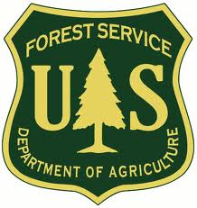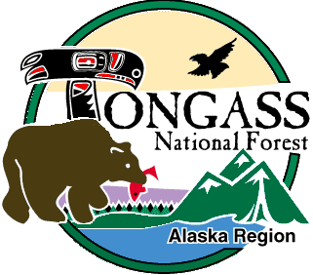

OUTREACH

**Pack Creek Bear Viewing Area Ranger**

**GS-0499- 3/4/5**

**Alaska Region - Tongass National Forest**

**Admiralty Island National Monument**

**Juneau, Alaska**

**Admiralty National Monument is seeking a Wilderness Ranger** for the [Pack Creek](http://www.fs.usda.gov/recarea/tongass/recreation/natureviewing/recarea/?recid=78650&actid=62) Bear Viewing Area within the[Kootznoowoo Wilderness Area](http://www.wilderness.net/NWPS/wildView?WID=300) and Admiralty Island National Monument. To express interest in this position, please complete the attached Outreach Response Form and send to [htullis@fs.fed.us](mailto:htullis@fs.fed.us) **by close of business Friday February 14th, 2014**. For additional information on this position or the duty location, please contact Harry Tullis at (907) 789-6232.

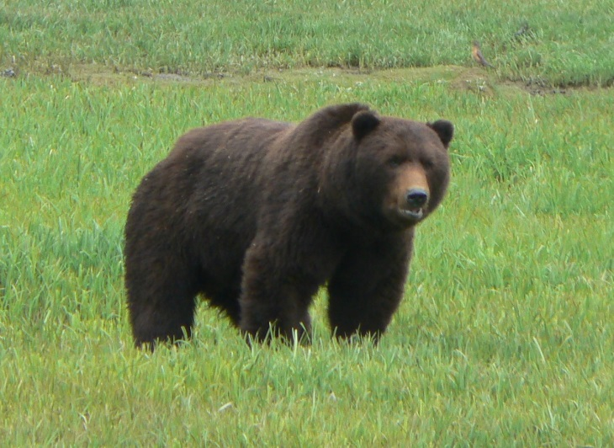

**Position Title**: Pack Creek Ranger GS-0499-3/4/5

**Tour of Duty:** This position will be advertised through Pathways as a Student Intern (Recreation) indefinite position (without a Not-To-Exceed date), which allows for non-competitive conversion to a permanent employee after successful completion of education degree requirements and on the job training. While the student intern completes the degree, the summer work schedule will occur around their school schedule (e.g June to August). Once the degree and job training are completed, this position will convert to a 13/13 permanent seasonal GS-0462-5 Forestry Technician (Wilderness) appointment with the work schedule April through September.

**Duty Station:** Juneau, Alaska

**Housing:** Government bunkhouse lodging will likely be available for a daily rate of about $15-$18.

**To Apply:** This position will be advertised on [the USAJOBs website](https://www.usajobs.gov/) as a Pathways Student Intern in February 2014.

|  |
| --- |
| **Position Duties**:  **Explains and enforces Pack Creek rules and other applicable federal and state regulations.**  Provides instruction to visitors on general bear safety and appropriate behavior around Pack Creek habituated bears.  **Engages visitors to provide in-depth information on the area.** Interprets a wide range of natural and cultural history including forest ecology as well as marine environments of Southeast Alaska.  **Plans and implements logistics required to support project goals.** Independently executes all duties associated with this public service program. Serves as a team member with extensive communication and coordination in the pursuit of program objectives.  **Supports program goals by managing visitors using established protocols.** Facilitates visitation by the collection of required fees and entry permits and by tracking use with monitoring forms. Seasonally write detailed reports on program outcomes.  **Due to work conditions in bear country, a successful candidate will be required to carry a firearm and is subject to drug testing.**  *Key duties include:*   * Consistently demonstrating positive attitudes toward safe work habits. * Being an effective team member providing individual contributions daily. Communicating with coworkers to ensure public safety and enhance visitor experience. * Enhancing visitors experience by communicating the wonder of Pack Creek and the Kootznoowoo Wilderness while subtly but effectively articulating rules critical to their safety. * Various duties associated with wilderness management including wilderness character monitoring, inventorying and cleaning up campsites and disseminating information on the Wilderness Act and Leave No Trace principles.  * Issuing permits to the public for the authorized entry to the Pack Creek Bear Viewing Area. Permit duties include collecting fees, reconciling cash receipts, entering permit information in a reservation database, completing onsite monitoring forms and writing end of the season use reports. * Daily maintaining equipment and regularly checking facilities for upkeep to avoid degradation affecting workload or safety. |

**Position requirements:**

The duties of the position require a tolerance for the close proximity to brown bears, the operation of small boats in inclement weather, the qualification with and the daily carrying of a large caliber firearm and the regular transport on small fixed wing planes.

**Duty Station:**

The district office is located in Juneau, Alaska. Admiralty Island National Monument and Juneau Ranger District staffs are co-located at 8510 Mendenhall Loop Road, near the renowned Mendenhall Glacier. The City of Juneau is the capital of Alaska which originated as a bustling gold mining community founded in 1880. It is the only State capital that cannot be reached by road. Juneau is on the mainland, and lies along the famed Inside Passage, which is a maze of protected waterways weaving around over a thousand islands. This area of the State is commonly known as "southeast" or "the panhandle".

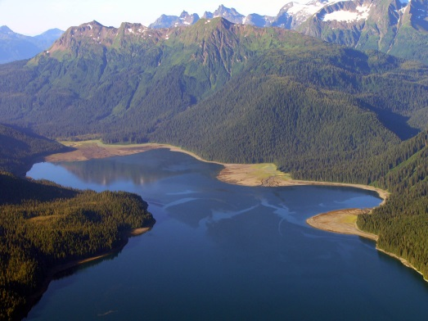

The Coast Range Mountains rise abruptly from the tidal flats of Gastineau Channel making a spectacular backdrop for downtown Juneau. The city has a population of approximately 30,000 people, and has strong Alaska Native, Filipino, and Asian representation. Diversity is found in the many civic and community organizations.

Juneau is located within the boundaries of America’s largest National Forest, the Tongass, which boasts nearly 17 million acres. Juneau is a major service center for southeast Alaska and provides a diverse selection of employment opportunities and businesses.

Please note: time in the field may be spent hiking, boating, kayaking, and staying at remote field camps. Field work requires performing arduous tasks in wet, cold, and mountainous terrain. Other work is performed in an office setting, interacting with other district resource specialists, Tongass National Forest stakeholders, and the general public. You’ll be utilizing databases and performing other tasks in support of program goals.

Because southeast Alaska is adjacent to the North Pacific, it has a maritime climate characterized by relatively mild, cloudy, and wet weather. Average annual precipitation ranges from 92 inches downtown, to 53 inches at airport (located 9 miles from the downtown area). Average annual snowfall is 98 inches at sea level. The average annual minimum temperature is 36.7 degrees, and the average annual maximum temperature is 48.5 degrees. Winter temperatures rarely drop below zero, and summer temperatures rarely reach into the 80's.

**Tongass National Forest website**: <http://www.fs.fed.us/r10/tongass/>

**Thank you for your interest in this position!**

*The U.S. Department of Agriculture Forest Service prohibits discrimination in all its programs and activities on the basis of race, color, national origin, sex, religion, age, disability, political beliefs, sexual orientation, and marital or family status (not all prohibited bases apply to all programs). Persons with disabilities who require means for communication of program information (Braille, large print, audiotapes, etc) should contact USDA’s TARGET Center at (202) 720-2600 (voice and TDD).*

*To file a complaint of discrimination write: USDA, Director, Office of Civil Rights, Room 326-W, Whitten Building, 14th and Independence Ave, SW, Washington, DC 20250-9401 or call (202) 720-5964 (voice or TDD). USDA Forest Service is an equal opportunity provider and employer.*

**OUTREACH NOTICE FORM**

**Tongass National Forest**

**Admiralty Island National Monument and Juneau Ranger District**

**Juneau, Alaska**

**Respond by Close of Business Friday February 14, 2014**

**Position Title/Series/Grade: Pack Creek Ranger GS-0499-3/4/5**

**Duty Location: Juneau, Alaska**

**Opportunity type: permanent part time**

I will check [**https://www.usajobs.gov/**](https://www.usajobs.gov/) for the announcement!

**PERSONAL INFORMATION:**

|  |  |  |  |
| --- | --- | --- | --- |
| **Name:** |  | **Date:** |  |
| **Address:** |  | **Phone:** |  |
| **City/State:** |  | **E-Mail:** |  |

|  |  |  |  |  |
| --- | --- | --- | --- | --- |
| **Are you currently a Federal employee:** | YES |  | NO |  |
| ***If yes*:**  **Current title/series/grade:** |  |  |  |  |
| **Current duty station location:** |  |  |  |  |
| **Briefly describe below why you will be a quality candidate for this position (continue to next page if necessary):** |  |  |  |  |