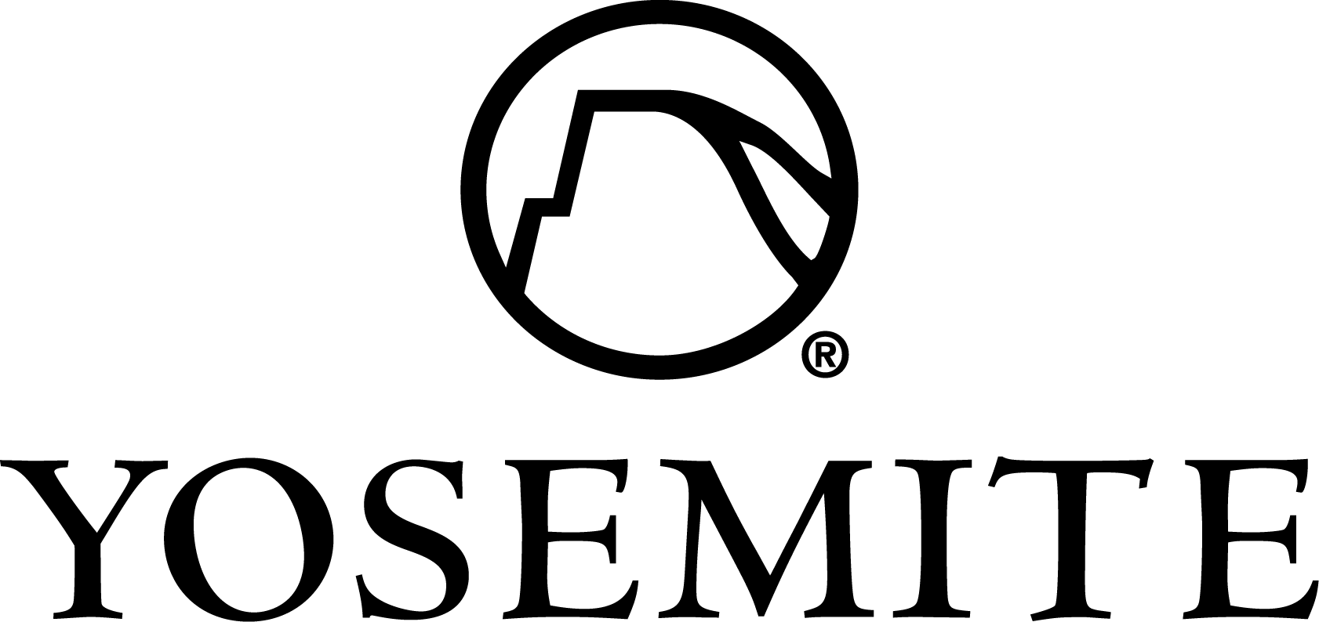

TITLE: INTERPRETIVE SERVICES ASSISTANT MANAGER

TYPE: Full-Time Permanent / 40 hours per Week
DIVISION: Interpretive Services

DEPARTMENT: Guest Recreation
REPORTS TO: Interpretive Services Manager
CLOSING DATE: APRIL 6, 2014

POSITION SUMMARY
The Interpretive Services Assistant Manager supports the Interpretive Services department in ensuring high quality interpretive programming for DNC Parks and Resorts at Yosemite. S/he acts as a catalyst in creating opportunities for visitors to form their own intellectual and emotional connections with the meanings and significance of Yosemite. S/he is responsible for supervising seasonal naturalist staff, overseeing all aspects of public programming, interpretive training, department scheduling, and offering interpretive programs.

ESSENTIAL FUNCTIONS
- Responsible for all aspects of managing the naturalist staff and interns, including hiring, supervision, training and coaching.
- Oversee all aspects of public programming, including new program development, logistics, ticketing, and park newspaper submissions.
- Develop and conduct interpretive training for Interpretive Services, other DNC departments, NPS and park
- partner staff.
- Maintain department calendars and schedules and disseminate through weekly program listings, tour desks, and the DNC website. Collaborate with other DNC departments, NPS and other park partners for program and event scheduling.
- Plan, create and execute thematic programs while encouraging active learning, critical thinking and stewardship.
- Responsible for other duties as assigned, such as administrative tasks, special projects, and special event planning for Yosemite.

REQUIRED EDUCATION & EXPERIENCE
- Baccalaureate Degree in Interpretation, Science, Natural Resources, History or relevant degree. In the absence of a Baccalaureate degree in Interpretation, candidate must have NAI CIG certification, equivalent Eppley Certification, or significant interpretation training.
- Experience developing and leading interpretive learning programs (classroom teaching is not equivalent).
- Experience supervising, training and coaching interpreters.
- Experience in management and/or administration.
- Experience working with children.
- Experience with web management and social media preferred.

REQUIRED KNOWLEDGE, SKILLS & ABILITIES
- Proficiency with computers and the Microsoft Office Suite.
- Strong leadership, interpersonal, management and communication skills.
- Must work well as a team and independently.
- Must be organized, punctual, self-directed, detail-oriented, flexible, creative, enthusiastic and motivated.
- Must be able to lead hikes of up to five [5] miles at 4,000 ft. or higher.
- Must be able to lift fifty (50) pounds on a regular basis.

REQUIRED KNOWLEDGE, SKILLS & ABILITIES CONTINUED…
- Must be willing to work varied shifts, weekends, evenings, and holidays.
- Must possess a valid California driver’s license.
- Knowledge of the Sierra ecosystems and cultural history preferred.
- Second language fluency preferred.
- Possession of current first aid and CPR certifications preferred.
- Background in the performing and/or visual arts preferred.

TO APPLY
- Submit a cover letter and résumé to Kara Stella, Assistant Manager of Interpretive Services, Delaware North Companies Parks & Resorts at Yosemite at kstella@dncinc.com.
- Also visit http://www.yosemitepark.com/AboutUs_Employment_HowtoApply.aspx to apply online via PeopleManager.
- Telephone 209-372-1257. Fax 209-372-1218. Email kstella@dncinc.com.
- Equal Employment Opportunity - Delaware North Companies, Incorporated and its subsidiaries consider applicants for all positions without regard to race, color, religion, creed, gender, national origin, age, disability, marital or veteran status, sexual orientation, or any other legally protected status. Delaware North is an equal opportunity employer.
- FINAL CANDIDATES FOR THIS POSITION WILL BE SUBJECT TO DRUG TESTING AND BACKGROUND INVESTIGATION.

