SEASONAL EMPLOYMENT OPPORTUNITIES

Natural Resources

SUMMER 2014

WILLAMETTE NATIONAL FOREST

DETROIT RANGER DISTRICT
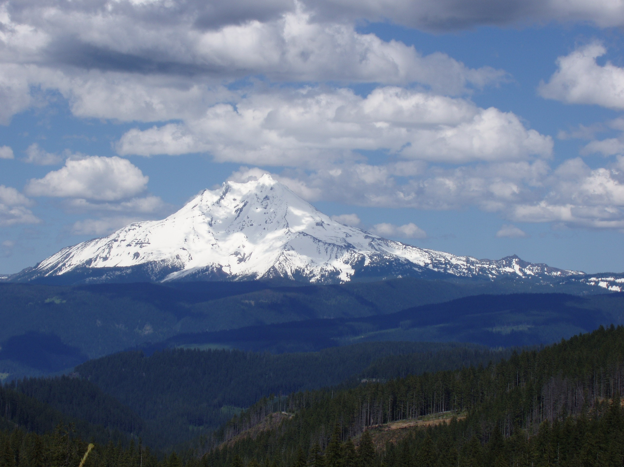

GENERAL OVERVIEW
The Willamette National Forest is seeking qualified candidates to fill potential temporary jobs on the Forest during the 2014 field season. These potential positions will be filled to support programs in Natural Resources. This outreach document provides interested candidates with information on possible temporary jobs including the position title, series/grade, job duties/requirements, and contact information. General information is also provided for the forest, ranger districts, and local communities.

Gross hourly pay rates
GS-3: $12.72 | GS-5: $15.98
GS-4: $14.23 | GS-7: $19.79
Positions available may include:
Biological Science Technician GS-3 – GS-7
Botany,
Wildlife,
Fisheries/Hydrology ,
Archeology

Duty Stations: Crews will be stationed at Detroit, Oregon.
Housing: Government provided housing may be available at Detroit. Cost is approximately $178/month.

Deadline for applications is March 15th

About the Detroit Ranger District
The Detroit Ranger District is the most northern District on the Willamette National Forest. The District encompasses about 300,000 acres, and includes outstanding features such as Mt. Jefferson Wilderness, Opal Creek Scenic Recreation Area and Wilderness, the North Cascades National Scenic Byway and the Detroit Lake Reservoir. The District has a large workload and keeps its 40+ permanent employees and approximately 50+ temporary employees very busy.
The elevation range for the District is between 1500 feet and 10,000 feet (Mt. Jefferson). The average temperatures range from 37° low to 49° high in December and 51° low to 82° high in August. Average yearly precipitation is around 80 inches, which occurs primarily from October to April. Snowfall occurs in December through February. The heavy recreation season occurs between Memorial Day and Labor Day when Detroit Lake is at full pool.

Housing is available. Housing for resource staff is 2 bedroom duplexes with 2 beds in each room. You may or may not share with another seasonal. Each unit has 2 bathrooms, kitchen and living room. Given the remote nature of the duty station, a personal vehicle is helpful for grocery and entertainment-related trips.

About the Detroit Community
The community of Detroit is situated in the heart of the Cascades—about 50 miles east of Salem, Oregon on Highway 22, and 80 miles west of Bend, Oregon. The District office is one mile west of the City of Detroit and is located in the Santiam River Canyon
At one time, Detroit was a logging community, but is now mostly a recreation oriented community. Detroit has about 300 permanent residents, but increases during the summer to about 500 residents. Summer activities include hiking, backpacking, river rafting & kayaking, hunting, fishing, and mountain biking, but a main summer attraction that draws thousands of recreationists each year is the Detroit Lake Reservoir. Detroit Lake is the most popular lake in Oregon and is known for its excellent water skiing, boating, fishing and camping. Winter activities include backcountry skiing, snowshoeing, snowmobiling, and snowboarding/downhill skiing at nearby Hoodoo Ski area and Mt. Bachelor.

About the Positions
Positions are involved in a variety of natural resource-related tasks that help support the District’s natural resource and timber programs.
Duties associated with the fisheries and hydrology positions may include contract preparation work such as stream structure design in streams, fish surveys, and hydrological surveys. These positions will also be involved in the District’s Respect the River program, an initiative to rehabilitate and restore dispersed camping sites on the District.
Wildlife duties may include habitat condition inventories and wildlife surveys. It may also include other duties such as snag and down wood surveys in preparation for contracts to create snags, down wood structures, and cavities for associated wildlife species; meadow maintenance; nest box installation; forage fertilization; and monitoring of browse cutback contracts.
The botany positions will include botanical surveys of rare plants, special habitats and noxious weeds. The work includes lots of hiking in multiple types of terrain, some harsh, rough habitat. Positions will include timber sale survey for rare plants, special habitats and invasive species and powerline corridor surveys for invasive species. Other jobs may include habitat rehabilitation and/or enhancement and other projects involving weed surveys, control and monitoring.

Field work is a major component of these positions. The Detroit Ranger District includes some steep terrain. Individuals working in these positions should expect to work outdoors rain or shine, in terrain that at times can be quite steep, and at tasks that may be considered strenuous.

Training will be provided and will include CPR/first aid, Defensive driving, 4x4 driving, radios, and all safety involved issues. Survey and field equipment such as GPS, navigational, maps, possibly GIS and local issues.

The positions available range from GS-3 – GS-5:
- The GS-3 requires 6+ months of pertinent experience or minimum 6 semester hours of coursework related to the job;
- The GS-4 requires 12+ months of pertinent experience or minimum 12 semester hours of coursework related to the job;
- The GS-5 requires 18+ months of pertinent experience or a Bachelor’s degree with a minimum 24 semester hours of coursework related to the job.

How to Apply
Go to https://www.usajobs.gov/
Step 1 – Create a USAJOBS account at www.usajobs.gov. It is recommended that as part of your profile you set up automatic email notification to be informed when the status of your application changes.
Step 2 - Create a Resume with USAJOBS or upload a Resume into your USAJOBS account. You may want to customize your resume to ensure it documents duties and accomplishments you have gained that are directly related to this position in order to verify that qualifications are met. In addition, your resume must support your responses to the online questionnaire (you may preview the online questionnaire by clicking on the link at the end of the How You Will Be Evaluated section of the job announcement). If you are using education in lieu of or as a supplemental to experience, transcripts are required to be attached.
Step 3 - Search for the job announcement number. Please read the entire announcement and all the instructions before you begin. Click "Apply Online" and follow the prompts to complete the Occupational Questionnaire and attach any additional documents that may be required. Make sure you select a potential duty station. You can update your application or documents anytime while the announcement is open. Simply log into your USAJOBS account and click on "Application Status." Click on the position
Title and then select Update Application to continue.
Position qualifications can be found at: http://www.opm.gov/qualifications/. Announcements for these positions will be posted on the USAJOBS websites.
Known Hiring changes for 2014:
- Open continuous recruitment (OCR’s) will no longer be available to apply for any seasonal position. (we will be assigned individual announcement numbers for different positions)
- Announcement numbers will be generated as requested by the supervisors, allowing for no more than a 14 day window to apply.
- It will be important to make contact with the supervisor via phone or completing and returning the outreach response form.
- You will need to check USAJOBS more frequently and be looking for specific places of work and job titles you are interested in.
- It is important to have your resume and profile updated in USAJOBS as you will only have 5-14 days to apply, Interested Applicants should apply to the following positions:
Job announcements: Biological Science Technician (Natural Resources) GS-0404-6/7, Biological Science Technician (Botany) GS-0404-04/05, Biological Science Technician (Wildlife) GS-0404-04/05, Biological Science Technician (Fisheries) GS-0404-04/05, Hydrologic Technician GS-1316-04/05, and Archeological Technician GS-0102-04/05
Be sure to choose Willamette National Forest, Detroit Ranger District as a preferred work location on the application form. This shows within the announcement as “multiple locations”.
And/Or
(2)
Pathways https://www.usajobs.gov/StudentsAndGrads
Program provides paths to Federal careers for students and recent graduates. The Pathways programs consist of the Internship Program, the Recent Graduate Program and the Presidential Management Fellows Program.
- National recruitment notices will go out in February and Sept.
- A service-wide conference call is tentatively scheduled for early February (anticipated to be February 5) for hiring managers.
- Vacancies will be approximately 7 days in length and tailored around core occupational series.
- ASC has a special Pathways team that will put out all vacancies.
- There will be separate Pathways vacancies for interns with an NTE date (former STEPS) and interns without an NTE date (former SCEPS)
- Interns with an NTE date can be extended but must remain FT or PT students to be in the program.

Start date is negotiable based on employee eligibility
Application Process:
In order to apply for Student Temporary Jobs on the Willamette National Forest, the following paperwork needs to be filled out and given to a supervisor that is interested in hiring you.
The forms you need are:
1. OF-612 Optional Application
2. OF-306 Declaration for Federal Employment
3. Copy of most Recent Transcripts
If you have any questions about completing the forms or have any questions concerning the Pathways program, please contact Human Resources at 1-877-372-7248.

For more information regarding specific seasonal positions, please contact:

Botany
Chris Wagner (Botanist) 503-854-3890
clwagner@fs.fed.us

Wildlife
Darryl Whitmore (Wildlife Biologist)
Email only please
dwhitmore@fs.fed.us

Hydrologist
Douglass Fitting 503-854-4217
douglasswfitting@fs.fed.us

Archeology
Cara Kelly (Archeologist) 503-854-4215
ckelly@fs.fed.us

Fisheries
Darrin Neff (fisheries Biologist)
503-854-4219
dneff@fs.fed.us

