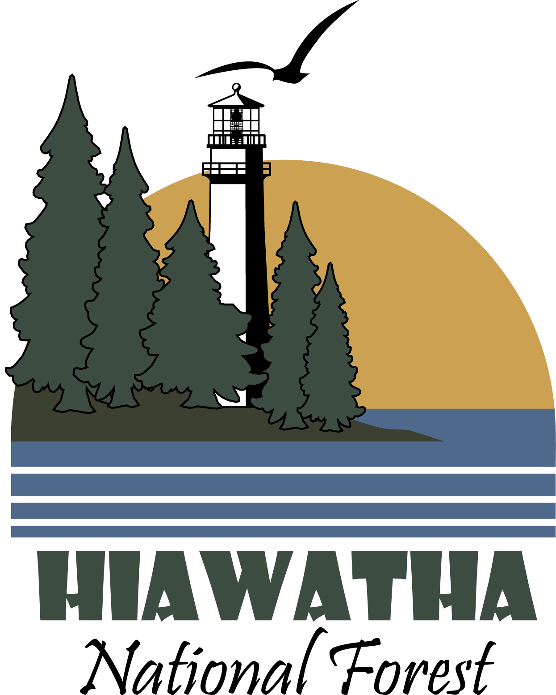
East Zone Fire Management
Hiawatha National Forest
GS 462- 04/05
February 18, 2014

Outreach

.
Prescribed burning for Jack pine regeneration and hazardous fuel reduction on the Hiawatha NF.

The East Zone of the Hiawatha National Forest plans to fill one or more GS-0462-04 Forestry Technician (Fire Suppression)and one GS-0462-05 Forestry Technician(Fire Engine Operator). This position is a temporary, seasonal (NTE 1039 hours) position with a duty station of St. Ignace, or Raco, Michigan. The incumbent will work within the East Zone of the Hiawatha National Forest.

The East Zone of the Hiawatha NF consists of the St. Ignace and Sault Ste. Marie Ranger Districts. The fire and fuels program on the Hiawatha NF is considered moderately complex. However, there are fuel types, weather conditions and wildland interfaces that can create complex prescribed burning and suppression challenges. During periods of low fire activity, the Hiawatha National Forest sends resources and overhead off-unit to wherever they are needed.

About The Position
The position serves as fire fighter on a wildland fire engine. Independently performs engine operation duties in the suppression of wildland fires and prescribed fire. Drives engine to fire locations in consideration of safety of crew and equipment and how the equipment can be best used in control and mop-up operations. Personally performs in starting pump engine, priming pump, adjusting engine speed and pump valves, laying hose, and using appropriate nozzles and nozzle adjustment in effective use of water and additives. Training will be provided to incumbent to be a fully qualified chain saw operator, or responsible for maintenance of specialized equipment used to respond to wildland urban interface/intermix situations. Ensures the engine is kept in a full state of readiness for emergency fire dispatch. This is a field going position and employees should expect to work in all types of weather conditions.

The vacancy announcement for this position is posted on the U.S. Government's official website for employment opportunities at USAJobs under vacancy announcement 14-TEMP110910-017288JT-DT, for the GS-04, and 14-TEMP110910-0173005JT-DT for the GS-05. These positions will open on February 20th, 2014. Those who wish to be considered for this position must apply to the vacancy announcement by March 17th, 2014 and indicate St. Ignace or Raco, MI as their desired duty station. The Referral List for this position will be issued to the selecting official no later than March 23rd, 2014. All applicants who have applied to the announcement on or before the listed dates and are found to be qualified and in the quality group will be referred for consideration. This is an arduous position. Prior wildland firefighting experience is a mandatory requirement for the GS-04 position.

Round Island Light House located on the St.Ignace District is on one of the two Islands the Hiawatha has to offer.

Duty Station
The St. Ignace District office is located approximately 6 miles West of St. Ignace, MI. The Raco Work Center is located in Raco, MI which is 20 miles west of Sault Ste. Marie, MI.

The Forest
Hiawatha National Forest lies in the eastern and central Upper Peninsula of Michigan. Approximately 1 million acres fall within the Forest boundary.

Hiawatha National Forest’s uniqueness stems largely from its proximity to three Great Lakes. The Great Lakes affect its weather, recreation opportunities, scenery, historic sites, hydrology and ecosystem diversity. The Forest’s recreation niche, “Your Great Lakes National Forest” captures some of this uniqueness by focusing on the Forest’s “Great Lakeshores” (Lakes Superior, Michigan and Huron), “Great Lighthouses” (Point Iroquois, North Light, East Channel Light, Christmas Range Light, Peninsula Point and Round Island Lighthouse); “Great Islands” (Grand Island, Round Island, and St. Vitals Island); and “Great Snow” (referring to the hundreds of inches of snow that fall each winter

Hiawatha National Forest is divided geographically into two units. The Forest’s East Unit includes the St. Ignace and Sault Ste. Marie Ranger Districts, including a work station located in Raco. The East Unit includes shoreline on Lakes Superior, Michigan and Huron. Munising Ranger District and Rapid River/Manistique Ranger District comprise the Forest’s West Unit. The West Unit includes shoreline on Lake Superior and Lake Michigan.

Other highlights of the Forest include:
- Six lighthouses located on NF land, including Point Iroquois light station, which is open to visitors. 5 Wild and Scenic Rivers.
- Whitefish Bay Scenic Byway and several national recreation trails.
- The East Zone has two island located within their boundary.

The weather in this area, due to the close proximity to Lake Superior and Lake Michigan, has high humidity and experiences four distinct seasons. Summers are warm and humid, with average high temperatures in the mid 80’s and average lows in the mid 60’s. Winters are cold, snowy and windy with temperatures often below freezing. Spring and autumn are mild with lower humidity.

Contacts:
For more information about this opportunity, feel free to contact me by email or telephone at:

Brenda Dale
East Zone Fire Management Officer, Hiawatha N.F.
(906)643-7900 Ext. 127 or bdale@fs.fed.us

