Science, Wisdom, & The Future:
Humanities Quest for a Flourishing Earth
A Noetic Sciences Lecture Series
The Evergreen State College, Spring & Summer 2017
In preparation for the total eclipse of August 21, 2017, we are hosting a series of lectures and events to raise awareness of science, story, and sustainability, and to discuss questions central to our understanding of science, technology, the arts, culture, human thought, and the role of citizen science to empower diverse individuals and communities at this time in history.
--Solar eclipse viewing glasses will be given away, courtesy of Russ and Cheryl Genet.

May 8, 2017 6:00 p.m. Lecture Hall 4
Join us on for presentations by Evergreen faculty and students

Allen Mauney,
“Special Relativity & the Connection to Science and Wisdom”
Rebecca Chamberlain,
“Interdisciplinary Approaches to Astronomy Education within Communities of Practice,” and “Sun, Moon, Earth: An Overview of the Solar Eclipse of 2017”
Emily Lubar, Physics Student
“Evergreen as a Pathway to Arecibo Observatory,”
Shannon Scott and members of Evergreen Astronomical Society

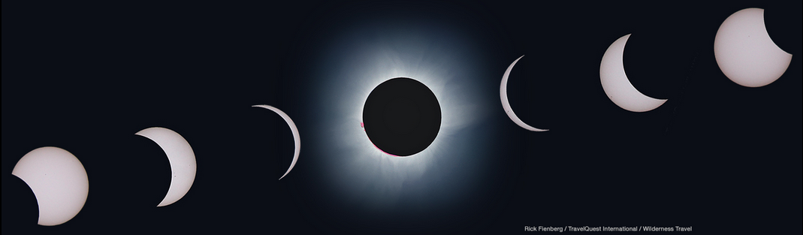
Other Events Include:
April 14 Day of Presence, “Black Suns: An Astrophysics Adventure” (1:30pm LH1)
May 1 Lois Landgrebe, “Salish Star Stories in Lushootseed” (6:00 pm, LH4)
May 22 Kathleen Ensenat, “One Way Trip: What are the Realities of Colonizing Mars, and What that Says About Earth?” (6:00 pm LH 4)
May 31 E.J. Zita, “Cosmology & Sustainability: People, Planet, Politics” (6:00pm LH 4)
May 17 Science, Wisdom, & the Future: Humanity’s Quest for a Flourishing Earth (7:00-10:00 LH4) Star-hunt afterwards, weather permitting.
--Russ Genet, PhD. Astronomy, “Cultural Evolutionary Forces, Citizen Science, & a
Flourishing Planet
--Cheryl Genet, Ph.D. Philosophy, “Living Wisely in a Scientific and Technological Age”
--12-1pm The Greener Store--Reading/Q &A/Book Signing

This series is made possible by: The Evergreen State College Foundation Noosphere Award; “Astronomy and Cosmologies;” and “Cosmology: Science, Wisdom, and the Future.”

