Pacific Northwest Region (R6)

Data Resource Management

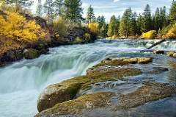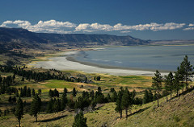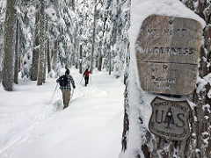

“Caring for the Land and Serving People”

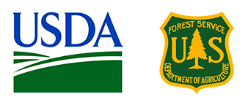

OUTREACH NOTICE

** ONE Permanent Full-Time Position**

Regional Web GIS Coordinator

(Geospatial Systems Specialist)
GS-0301-12
The Pacific Northwest Region of the U.S. Forest Service may soon be announcing one permanent, full-time GS-301-12 Geospatial Systems Specialist position. This is a regionally managed position that can be located at the Regional Office or a hosted duty station within Region 6. The incumbent will serve as subject matter expert for the development and application of web-enabled geospatial information systems and will leverage geospatial technology to support the mission and programs of the Region.
For additional details on the position, you may call Matthew Wilson (503) 679-0612.

If you are interested in this position, please return the Outreach Response form at the end of this document by the close of business on January 22nd, 2018 to Matthew Wilson, matthewwilson@fs.fed.us.

Summary of the Position:

This position is part of a regional team supporting regional and forest projects with geospatial data creation, analysis and management, technical support, and map production. Geospatial System Specialists assist in managing/maintaining geospatial data and support customers in using GIS technology for their projects. Our GIS products and services include web maps, mobile GIS support, spatial analysis, publication maps, spatial data requests, geoprocessing tools and more. Examples of specific duties associated with this position include (but are not limited to):
DUTIES:

- Assist DRM Program Managers with directing regional projects and assigning Web GIS related work
- Provide briefings and presentations as needed to Regional and National leadership
- Coordinate project assignments and tasking with R6 Mobile GIS Coordinator
- Work closely with the R6 Office of Communication and Community Engagement (OCCE), Natural Resources, Recreation and other regional directorates to develop and expand the Web GIS products and workflows
- Work with National and Regional counterparts to further develop procedures, policy and guidance
- Coordinate and facilitate R6 Web GIS Meetings
- Serve as lead ArcGIS Online (AGOL) administrator and liaison to the Enterprise Web GIS team for Region 6
- Manage Regional AGOL accounts and coordinate technical support for the R6 Web GIS user community
- Empower the public and Agency decision makers with tools and information using the ArcGIS Platform (ArcGIS Desktop, ArcGIS Server, ArcGIS Mobile, ArcGIS SDE, ArcGIS Online)
- Utilize GIS technology and established GIS procedures to produce maps and graphics for various Forest resource programs, planning documents, and a variety of other requirements.
- Assist with the organization and maintenance of resource information and data to facilitate analysis across multiple disciplines including but not limited to recreation, silviculture, planning, engineering and fire.
- Manipulate and analyze geospatial data to support resource management decisions for multiple resource, jurisdictional, and ownership units or a large geographical region.
- Perform multi-scale and/or multi-resource analysis in support of planning, analysis, and monitoring activities.
- Assist the Region and Agency with the building of web, mobile and desktop apps that incorporate mapping, visualization and analysis

DUTY STATION:
We are considering a variety of duty station locations within USDA Forest Service Pacific Northwest Region 6 in Customer Service Area 1, Customer Service Area 2, Customer Service Area 3, Customer Service Area 4 or Customer Service Area 5 (see detailed description below). Duty Stations currently being considered for this position are Baker, OR; Bend, OR; Corvallis, OR; Everett, WA; Grants Pass, OR; Klamath Falls, OR; La Grande, OR; Lakeview, OR; Portland, OR; Prineville, OR; Sandy, OR; Springfield, OR; Wenatchee, WA.
Description of the US Forest Service Region 6:

The Pacific Northwest Region 6 of the US Forest Service contains 17 National Forests, two National Scenic Areas, a National Grassland, and two National Volcanic Monuments, all within the States of Oregon and Washington. These national forests provide timber for people, forage for cattle and wildlife, habitat for fish, plants, and animals, and some of the finest recreation lands in the country.
Description of Data Resources Management (DRM):
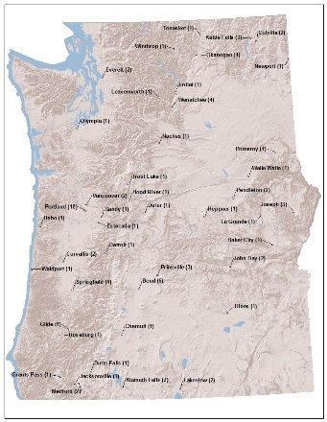
DRM is a service provider of geospatial and business solutions to the resource areas within the Regional Office as well as the National Forests within the Pacific Northwest. Our organization consist of over 95 professionals providing support for Geographic Information System (GIS) analysis and mapping; production of cartographic publication maps; regional data standardization; national data calls including Geographic Performance and Accountability; Region 6 intranet platform maintenance and improvement; 508 compliance; training and information regarding Personally Identifiable Information (PII); application tool development; database development and maintenance; records management including forms and directives; and advanced remote sensing support.
We accomplish our diverse mission requirements as a regional asset while being deployed at duty stations at National Forests and Ranger Districts throughout the Pacific Northwest.

DRM Customer Service Areas (CSA) serve as the primary “frontline” support arm of our Geospatial Solutions network, providing professional Geospatial products and services to resource specialists and managers throughout Region 6.
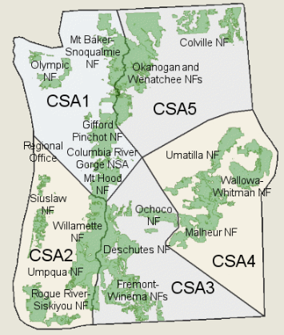
- CSA 1 - Columbia Gorge National Scenic Area, Gifford Pinchot, Mt. Baker-Snoqualmie, Mt. Hood, Olympic, R6 Regional Office and PNW Research Station Headquarters, PNW Olympia Lab, PNW Portland Lab, and PNW Seattle Lab
- CSA 2 - Rogue River-Siskiyou, Siuslaw, Umpqua, Willamette, PNW Corvallis Lab
- CSA 3 - Deschutes, Crooked River National Grassland, Ochoco, and Fremont-Winema
- CSA 4 - Malheur, Umatilla, Wallowa-Whitman, with PNW LaGrande Lab
- CSA 5 - Colville, Okanogan-Wenatchee

Description of the Pacific Northwest:
The Pacific Northwest consists of the states of Oregon and Washington. The largest metropolitan areas are Seattle, Washington, with 3.7 million people and Portland, Oregon, with 2.4 million people. The Pacific Northwest is a diverse geographic region, from the Pacific Ocean in the west and several mountain ranges crisscrossing the region, including the Coast Mountains, the Cascade Range, the Olympic Mountains, the Columbia Mountains, the Siskiyou Mountains and the Blue Mountains. These mountain ranges are home to over a quarter of all active volcanos in the lower 48, including the Pacific Northwest highest peak, Mount Rainier, in the Washington Cascades, at 14,410 feet (4,392 m). Its geographic diversity provides numerous opportunities for outdoor recreation including, off-roading and ATV riding, snowmobiling, alpine skiing, snowboarding, horseback riding, hiking, kayaking, rafting, fishing, mountain biking, water sports.
Oregon State Chamber of Commerce
Washington State Chamber Of Commerce

Climate:
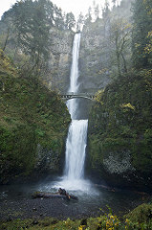
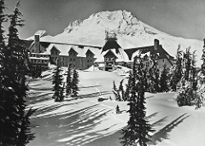
The Pacific Northwest experiences a wide variety of climates. An oceanic climate ("marine west coast climate") occurs in most coastal areas, typically between the ocean and high mountain ranges. An Alpine climate dominates in the high mountains. Semi-arid and arid climates are found east of the higher mountains, especially in rain shadow areas. Portland, Oregon is located in the Willamette Valley near the confluence of the Willamette and Columbia Rivers. Summer days are mostly cloudless with highs in the 70’s – 90’s, occasionally topping 100. Spring and fall days are consistently between 50 and 70 degrees, with occasional surges of summer-like or winter-like temperatures that rarely last more than a week. In the Winter, very cold days where the daytime high fails to rise above freezing are rare and may occur only two or three days per year, and occasionally not at all, especially in the lowest elevations of the in the valleys.

Education:
Pre-schools through high schools can be found in the most communities. There are many universities and community colleges offering quite reasonable tuition. Day care facilities also are available in most communities. Additionally, there are a large variety of private universities in the region.

Houses of Worship:
Houses of Worship representing all major faiths can be found throughout the region.

Non-Discrimination Statement
In accordance with Federal civil rights law and U.S. Department of Agriculture (USDA) civil rights regulations and policies, the USDA, its Agencies, offices, and employees, and institutions participating in or administering USDA programs are prohibited from discriminating based on race, color, national origin, religion, sex, gender identity (including gender expression), sexual orientation, disability, age, marital status, family/parental status, income derived from a public assistance program, political beliefs, or reprisal or retaliation for prior civil rights activity, in any program or activity conducted or funded by USDA (not all bases apply to all programs). Remedies and complaint filing deadlines vary by program or incident.
Persons with disabilities who require alternative means of communication for program information (e.g., Braille, large print, audiotape, American Sign Language, etc.) should contact the responsible Agency or USDA’s TARGET Center at (202) 720-2600 (voice and TTY) or contact USDA through the Federal Relay Service at (800) 877-8339. Additionally, program information may be made available in languages other than English.
To file a program discrimination complaint, complete the USDA Program Discrimination Complaint Form, AD-3027, found online at http://www.ascr.usda.gov/complaint_filing_cust.html and at any USDA office or write a letter addressed to USDA and provide in the letter all of the information requested in the form. To request a copy of the complaint form, call (866) 632-9992. Submit your completed form or letter to USDA by: (1) mail: U.S. Department of Agriculture, Office of the Assistant Secretary for Civil Rights, 1400 Independence Avenue, SW, Washington, D.C. 20250-9410; (2) fax: (202) 690-7442; or (3) email: program.intake@usda.gov.

OUTREACH RESPONSE FORM
USDA Forest Service
Pacific Northwest Region 6
Data Resources Management
Geospatial Systems Specialist, GS-0301-11
If you are interested in this outreach notice, please complete and return this form to:
Katy Madrid (541) 426-5686, kathrynmadrid@fs.fed.us or Matthew Wilson (503) 679-0612, matthewwilson@fs.fed.us by January 22, 2018

NAME:

E-MAIL ADDRESS:

MAILING ADDRESS:

TELEPHONE NUMBER:

 | {USFS |  |  | {OTHER
AGENCY EMPLOYED WITH:

 | {PERMANENT |  | {TEMPORARY |  | {OTHER
TYPE OF APPOINTMENT:

 | {REGION |  | {FOREST
CURRENT:

{DISTRICT

 | {SERIES |  | {GRADE

CURRENT:

{POSITION TITLE
CURRENT:

HOW DID YOU FIND OUT ABOUT THIS OUTREACH NOTICE?

Are you eligible for appointment under any of the following special authorities?
____ Former Peace Corps
____ Person with Disabilities
____ Student Employment Program
____ Veteran with 30% Compensable Disability
____ Veteran’s Employment Opportunities Act of 1998
____ Veteran’s Readjustment
____ Reinstatement Eligibility
____ Other (please specify) __________________________

