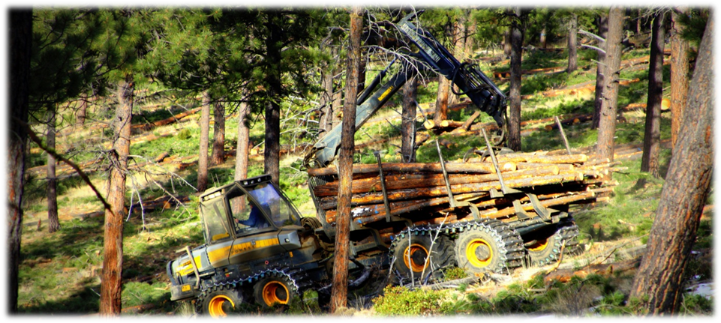
OUTREACH NOTICE

DESCHUTES NATIONAL FOREST

BEND/FORT ROCK RANGER DISTRICT

BEND, OREGON

Forestry Technician (Presale)

Permanent Seasonal GS-0462-05

(3 vacancies)

The Deschutes National Forest will soon be advertising three GS-0462-05 Forestry Technician positions. The position is a Permanent Seasonal (13/13) appointment, and will be located at the Bend/Fort Rock Ranger District in Bend, Oregon.
The purpose of this Outreach Notice is to determine the potential applicant pool for this position and to establish the appropriate recruitment method and area of consideration for the advertisement. Responses received from this outreach will be relied upon to make this determination.

Please complete the outreach response form within the outreach database to indicate your interest in the position. https://fsoutreach.gdcii.com/Outreach

THE POSITION
These senior crew member positions serve on the district marking crew, performing a variety of timber sale preparation duties that include but are not limited to: timber marking, timber cruising, and sale layout as part of the district’s timber management program. These positions also act as additional leadership among a 5-7 person timber marking crew, and assist the crew lead in a variety of duties to prepare for the work week/day.

On average, the district produces 30 MMBF across 6,000 to 8,000 acres annually.

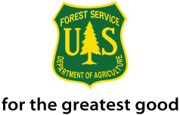
Much of the work involves the supervision of timber marking. Applicants must be able to interpret complex silvicultural prescriptions and marking guides, bringing to the attention of responsible individuals situations on the ground that are inconsistent with the prescription or marking guide. Good communication skills, a positive attitude and strong work ethic are highly desirable along with knowledge of forest measurement tools and techniques including the use of Spiegel Relaskop, clinometer, laser measurement tools, Trimble GPS, map and compass and prism.

ABOUT THE AREA
The City of Bend (http://www.bend.or.us) is a rapidly-growing metropolitan area located in the central portion of the state, on the east side of the Cascade Mountains. This “High Desert” community is a full-service community that serves as a hub for medical, educational, recreation and entertainment needs for a large geographic area in Central Oregon. Tourism plays an important role in the local economy and regional economy.
COMMUNITY INFORMATION
Elevation: 3,623 feet
Population: City – ~91,000
County: Deschutes
Location: East side of the Cascade Mountains in Central Oregon
20 miles southeast of Sisters, Oregon
15 miles south of Redmond, Oregon
Average Summer Temperatures: 85º/day 44º/night
Average Winter Temperatures: 41º/day 21º/night
Average Annual Precipitation: 12” (mostly in the form of winter snow)
Closest Commercial Airport: Redmond, Oregon (an easy 15-mile drive to the north);
serviced by United, Delta, and Alaska Airlines
SCHOOLS
Bend is served by public and private schools from pre-school through high school. Public schools are administered by the Bend-LaPine School District (http://www.bend.k12.or.us) . College level community education courses and two year degree programs are offered locally in Bend, and at satellite campuses, through Central Oregon Community College (COCC) (http://www.cocc.edu). Additionally, OSU Cascades offers four-year degrees through Oregon State University and the University of Oregon (http://www.osucascades.edu).
HEALTH CARE
Bend is the primary center for high quality health care in Central Oregon with one major hospital (http://www.stcharleshealthcare.org), numerous clinics, and the associated full array of medical support and services. Redmond, located approximately 15 miles north of Bend, also has a community hospital and associated high quality medical support and services.
HOUSING
As a rapidly growing city and region, real estate is readily available. The median sales price for a residential three bedroom home is around $420,000 and 3 bedroom rentals average $1,800 per month. Prices in Redmond are typically lower ($286,000 and $1,500 respectively).
ANNUAL EVENTS
The local area is well known for its many annual events, including: Winterfest (February), Bend Summer (July) and Fall Festivals (October), Arts in the High Desert (August, ranked in the top 15 nationally for fine arts shows), Bend Film Festival (October). Classical music is performed by the Central Oregon Symphony in Bend during the winter months.
Annual athletic and recreational events also take place on forest lands under special use permit.
The Pole, Pedal, Paddle race (May) is a well recognized event in Oregon and surrounding states.
The Cascade Cycling Classic (July) a week of professional and amateur races, Mt. Bachelor ski area(http://www.mtbachelor.com) 25 miles, and Hoodoo Ski Area (http://www.hoodoo.com) 40 miles, provide excellent skiing opportunities. Mountain bike trails are abundant, with the Phil’s
trail system very highly regarded.

A diversity of other events and concerts are regularly held at the refurbished downtown Tower Theatre (http://www.towertheater.org), as well as outdoor concerts at the Les Schwab Amphitheater (http://www.bendconcerts.com) and Athletic Club of Bend (http://www.athleticclubofbend.com). The nearby communities also offer many festivities, including the Sisters Rodeo and Parade (June), Outdoor Quilt Show (July), Sisters Folk and Jazz Festivals (September), Sunriver Music Festival (August), and free music venues throughout the summer in both Bend and Redmond. The County Fairgrounds in nearby Redmond hosts numerous events, as well as major entertainment on a regular basis.

For additional details on the position, you may call Jeff Finley, Supervisory Forest Technician at (541) 383-4780.
There is no government housing available for this position.

Vacancies will be advertised on USAJobs at https://www.usajobs.gov.

The U.S. Department of Agriculture (USDA) prohibits discrimination in all its programs and activities on the basis of race, color, national origin, age, disability, and where applicable, sex, marital status, familial status, parental status, religion, sexual orientation, genetic information, political beliefs, reprisal, or because all or part of an individual’s income is derived from any public assistance program. (Not all prohibited bases apply to all programs.) Persons with disabilities who require alternative means for communication of program information (Braille, large print, audiotape, etc.) should contact USDA’s TARGET Center at (202)720-2600 (voice and TDD). To file a complaint of discrimination, write to USDA, Director, Office of Civil Rights, 1400 Independence Avenue, S.W., Washington, DC 20250-9410, or call (800) 795-3272 (voice) or (202) 720-6382 (TDD). USDA is an equal opportunity provider and employer

OUTREACH RESPONSE FORM
Timber Sale Prep Crew – GS-0462-05
Permanent Seasonal 13/13 Appointment
Deschutes National Forest – Bend Fort Rock RD
Respond by August 21, 2018

APPLICANT INFORMATION:
NAME:
E-MAIL ADDRESS:
MAILING ADDRESS:
STREET ADDRESS:
CITY, STATE, ZIP CODE:
TELEPHONE:

CURRENT STATUS:
Agency: | USFS | BLM | Other
Type of Appointment: | Permanent | Temporary | Term | VRA | PWD | Other
Region:
Forest:
District:
Series:
Grade:
Position Title:

If you are not currently a permanent (career or career conditional) employee, are you eligible to be hired under any of the following special authorities?
People with Disabilities
Veterans Recruitment Act
Disabled Veterans w/30% Compensable Disability
Veterans Employment Opportunities Act of 1998
Former Peace Corps Volunteer
Student Career Experience Program
Other

Please return your completed form and an attached resume before the close of business on August 21, 2018. Inquiries can be sent via email or surface mail to: jeffreyrfinley@fs.fed.us

Deschutes National Forest
Bend Fort Rock Ranger District
Attn: Jeff Finley
63095 Deschutes Market Road
Bend, OR 97701

