OUTREACH NOTICE | Mt. Hood National Forest  R6- Pacific Northwest Region | 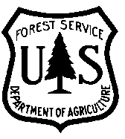

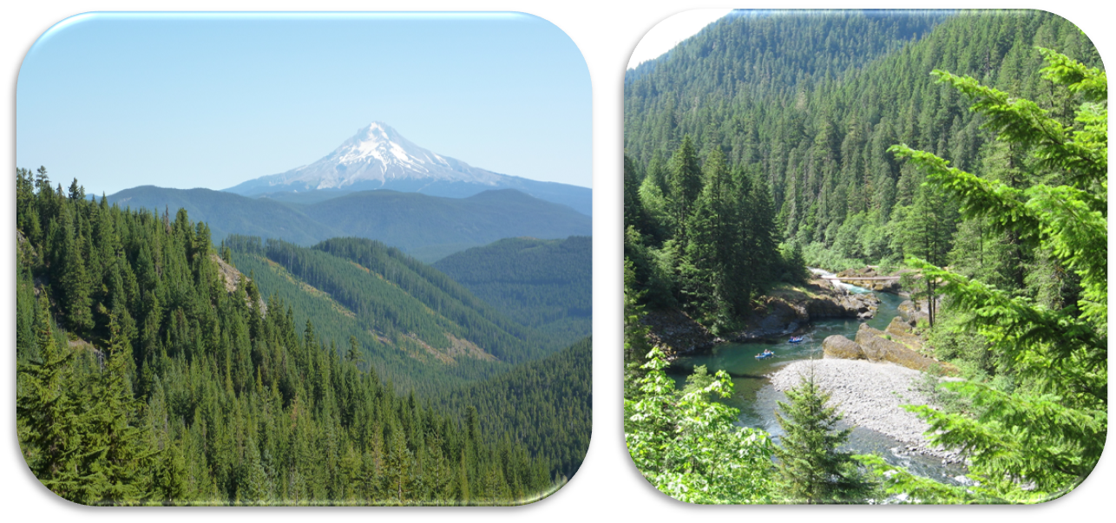

Fish Biologist
GS-0482-09
Permanent Full Time
Zigzag Ranger District, Zigzag, OR

If interested, please respond by sending your resume to Greg Wanner, Supervisory Fish Biologist, using the outreach response form at the bottom of this document. Send response by August 22, 2018. This position vacancy announcement will be advertised on usajobs.gov sometime in late-August through mid-September and may only be open for five days.

The candidate for this position must have demonstrated technical skills using GIS that has supported land management direction and decisions or answered research questions. The candidate must also have demonstrated strong writing and oral communication skills.

The Zigzag Ranger District of the Mt. Hood National Forest, located in northwest Oregon, will soon be filling a Fish Biologist, permanent full time position, at the GS-0482-09 level. This outreach notification is being circulated to inform prospective applicants of this upcoming opportunity, and to help the hiring official gain insight into the potential pool of candidates.

This position serves as a fisheries biologist on interdisciplinary teams responsible for designing restoration projects ranging from improving aquatic organism passage to enhancing fish habitat by placing large wood in streams. Ensures projects comply with forest management plans and ESA consultation guidelines; coordinates studies of fishery populations; and prepares a variety of written reports and environmental analyses. Includes gathering, compiling, and analyzing data to determine fish habitat needs; determining key spawning, rearing, recommending solutions to special issues or problems involving fishery resources; and determining the need for and designing of fish habitat improvement projects; developing project plans for inclusion in Forest program of work; and studying and recommending solutions to special coordination problems involving fish habitat protection.

About the Pay, Hours, and Benefits
This is a permanent full-time GS-09 position with an annual salary ranging from $50.598 to $65,778 (dependent upon time in current grade or experience). Normal days of work are Monday through Friday; however, the work schedule may be adjusted to meet the needs of the public or partner groups. Government Housing may be available. No Transfer of Station (TOS) is authorized however, recruitment and relocation incentives may be considered.

ABOUT THE FOREST:
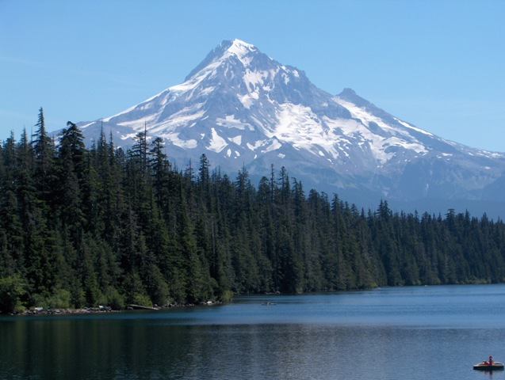
Located twenty miles east of the city of Portland, Oregon, the 1.1 million acre Mt. Hood National Forest is framed by the Columbia River Gorge National Scenic Area to the north, the metropolitan area to the west, the Willamette National Forest and Confederated Tribes of Warm Springs Reservation to the south, and the sweeping dry lands of central Oregon to the east. One of the State of Oregon’s iconic landmarks, the 11,240-foot peak of Mount Hood stands in the middle of the Forest and is the state’s highest point.
Straddling both sides of the Cascade Mountain Range, the Forest comprises and serves two distinctly unique areas. The west-side of the Forest is in close proximity to the Portland/Vancouver metropolitan area, with a population over 2 million. The interface experiences intense levels of recreational use, developed and dispersed; a broad diversity in the socio-economic and cultural diversity of the area’s citizens and the Forest’s users; and a high degree of interest from members of the urban public and media. By contrast, the communities on the east-side of the Forest are more rural in nature, with a unique sense of relationship to place and a larger dependence upon the natural resource assets.
East-side or west-side, the Forest draws visitors from around the Pacific Northwest and the Nation. Nearly 4.5 million people per year come to view the wildlife and wildflowers, camp, hike, boat the lakes, play in the streams, ski, mountain bike, hunt, fish, climb Mount Hood, and participate in a range of recreational activities in and around the Forest. Some popular destinations on the forest include Timberline Lodge, built in 1937 high on Mt. Hood, Lost Lake, Trillium Lake, Timothy Lake, Rock Creek Reservoir and portions of the Old Oregon Trail, including Barlow Road.
Stewardship of the Mt. Hood National Forest and its natural and cultural resources presents a unique set of management challenges, as well as many opportunities to interact with the public in meaningful ways.
There are approximately 311,000 acres of designated wilderness on the Forest, in eight separate wilderness areas. The largest is the Mt. Hood Wilderness, which includes the mountain's peak and its upper slopes. Check out our website at: www.fs.usda.gov/mthood/

ABOUT THE ZIGZAG RANGER DISTRICT:
The Zigzag Ranger District is located in Zigzag, Oregon. The District is comprised of 279,000 acres and is located near Portland metropolitan area of over a million residents. The district manages a large recreation program including 551 summer homes, 30 developed campgrounds, 3 ski areas including Timberline Lodge (Timberline Lodge has nearly 2 million visitors a year, and is one of only three National Historic Landmarks in the Forest Service System), many special use permits, over 300 miles of trails, and 2 wilderness areas. The district also manages the Bull Run Watershed cooperatively with the City of Portland, which supplies drinking water to the Portland metropolitan area. The compound of the Ranger District is historic, constructed in the 1930’s by the CCC. Many of the original buildings still remain.

Zigzag, Oregon is a small community with a population of 1,500 year round. It is located 52 miles east of Portland, 20 miles east of Sandy, Oregon, 12 miles from Timberline Lodge, Mt. Hood ski area, 45 miles west of Hood River, and 120 miles east of the Oregon coast. Recreational opportunities are abundant, including skiing, hiking, biking, windsurfing, fishing and hunting.

ABOUT ZIGZAG & MOUNT HOOD VILLAGE:
Zigzag and the Mount Hood Village (Welches, Brightwood) is nestled against the Cascade Range foothills, on scenic Highway 26. Zigzag is just over an hour’s drive from Portland, about 40 minutes from Gresham and Oregon City, and many District employees commute from these or other communities, including Sandy and Molalla (30 minutes away).

Zigzag, Welches and Rhododendron are a bedroom community to the Portland Metropolitan area; many of its residents commute daily into the city. Major employers in Zigzag are the U.S. Forest Service and the tourism industry.

GETTING THERE: Zigzag is located on U.S. Highway 26.

SCHOOLS: Locally, there is a grade school and a junior high school. The closest senior high school is in Sandy, Oregon, 30 minutes from Zigzag.

HOUSING: A bunkhouse may be temporarily available for this position. Housing is available for sale or rent. Many district employees also commute from Gresham, Sandy, Oregon City, Portland or other nearby communities.

If you are interested in this Permanent Full Time Fish Biologist Position

If you are interested in this position, please respond to Greg Wanner, by completing the attached Outreach Response Form, including a copy of your resume and returning it via e-mail. Please feel free to include a brief narrative regarding how your skill set makes you the ideal candidate for this position. Reply by August 22, 2018.

If you would like further information on the position please contact:

Greg Wanner, Supervisory Fish Biologist: gwanner@fs.fed.us, 503-622-2002

The U.S. Department of Agriculture (USDA) prohibits discrimination on all its programs and activities on the basis of race, color, national origin, gender, religion, age, disability, political beliefs, sexual orientation, and marital or family status. (Not all prohibited bases apply to all programs.) Persons with disabilities who require alternative means for communication of program information (Braille, large print, audiotape, etc.) should contact USDA’s TARGET Center at (202) 720-2600 (voice and TDD). To file a complaint of discrimination, write USDA, Director, Office of Civil Rights, Room 326-W, Whitten Building, 14th and Independence Avenue, SW, Washington, DC 20250-9410 or call (202) 720-5964 (voice and TDD). USDA is an equal opportunity provider and employer.

OUTREACH RESPONSE
Fish Biologist, GS-0482-09, Permanent Full Time
Mt. Hood National Forest, Zigzag Ranger District
Please send this completed form to Greg Wanner, (503) 622-2002, gwanner@fs.fed.us.

Name: ______________________________________________________Date:__________________

E-Mail Address: ____________________________________________________ ______

Mailing Address:______________________________________________________________________

___________________________________________________________________________________

Telephone Number:__________________________________________________________________

Agency Employed With: USFS BLM OTHER

Type of Appointment: ___________ Permanent Temporary TERM
______VRA PWD OTHER

Current Region/Forest/District: _______________________________________________

Current Series and Grade if Applicable: ____________________________________________

Current Position Title: _________________________________________________________

If not a current permanent (career or career conditional) employee, are you eligible to be hired under any of the following special authorities:

Person with Disabilities (Schedule A Appointing Authority)
Veterans Recruitment Appointment (VRA)
30% or More Disabled Veteran
Veterans Employment Opportunities Act of 1998, As Amended (VEOA)
Former Peace Corps Volunteer
Student Career Experience Program (SCEP)
Other: ____________________________________________________________________

Be sure to include copy of your resume as part of your response package.

How did you learn about this employment opportunity?

Thank you for your interest in this vacancy.
Mt. Hood National Forest is an equal opportunity employer

