Region Wide - OUTREACH
USDA Forest Service
Pacific Northwest Research Station Corvallis Forestry Sciences Laboratory

Multiple temporary Biological Sciences Technician (Bioacoustics) positions (GS-0404-05 & 07) will be available at the Corvallis, OR Forestry Sciences Lab to assist in bioacoustics data collection and analysis.

The following positions will be open when available on USAjobs and close 7 days later

Position Announcement Number | Duty Station
Biological Sciences Technician (Wildlife) GS-7 To be added | Corvallis, Oregon
Biological Sciences Technician (Wildlife) GS-5 To be added | Corvallis, Oregon

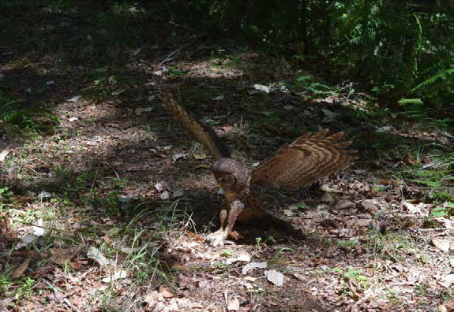

Introduction
The Pacific Northwest Research Station will soon begin filling multiple (at least 8) Biological Science Technician positions for the 2019 field season. We expect to have 1 opening at the GS-7 level and 7 openings at the GS-5 level.

These are TEMPORARY SEASONAL (1039) wildlife technician positions with a maximum six month tour schedule. The anticipated start date is March 5, 2019 and conclude August 31, 2019. Housing costs are not provided and the duty station does not have agency associated housing available. Applicants for positions will be responsible for their own housing and transportation to and from the duty station office location. Positions will be full-time (40+ hours/week).

Summary of Position

Primary responsibilities include:

- Deploying, maintaining, and retrieving autonomous recording units to monitor for the presence of multiple forest wildlife species.
- Driving, snowmobiling, snowshoeing or hiking to field locations.
- Navigating (including orientation using GPS, map and compass) often off trail across steep, rough, uneven, unstable, and brushy slopes in various weather conditions.
- Staying overnight in the backcountry possible for some of the field season.
- Performing miscellaneous tasks as needed to facilitate fieldwork, including:
  - Keeping accurate field notes, documentation, and report writing.
  - Entering data and transferring acoustic files onto permanent storage media.
  - Validating functioning of units prior to deployment and in the field.
  - Independently troubleshooting equipment errors in the field.
If selected, candidates will be expected to work a flexible schedule that will be mostly during the day but may include night or split shifts. Selected individuals will be expected to work in inclement weather and other adverse environmental conditions and to follow prescribed protocols. Candidates must be capable of walking or snowshoeing over 10 miles per day on steep terrain carrying up to a 50lb backpack. Successful candidates will demonstrate independence and problem solving skills dealing with computers, autonomous recorders, and GPS units. Candidates should be experienced navigating with topographic maps and compass. Candidates should have excellent driving skills, a good driving record and be comfortable working alone in remote locations. Applicants also will be required to pass a Federal Background check and obtain or maintain a Forest Service driver’s license. Preferred candidates will be familiar with the vocalizations of Pacific Northwest wildlife species.

How to Apply

Applicants must apply online at https://www.usajobs.gov/. You will be required to create a USAJOBS account and either create a resume or upload your own. Use the position titles listed to navigate to the appropriate position. Click “Apply Online” and follow the prompts to complete the online application.

Required Documents

For a complete list of required documents, refer to the USAJOBS vacancy announcement, but you are required to include the following:
- Resume that includes the following information: 1) job information for which you are applying; 2) personal information; 3) education; 4) work experience; and, 5) other qualifications.
- College Transcripts if education is required for meeting basic qualifications and/or you are substituting education for specialized experience. An unofficial copy is sufficient with the application, however, if selected an official college transcript will be required.
- DD-214 and/or SF-15 Application for 10-point Veteran Preference if claiming Veterans’ Preference or eligibility for appointment under the VRA, VEOA, or 30% Disabled Veterans hiring authority.

Selection Considerations for GS 5
- Successful completion of a full 4 year course of study leading to a bachelor's degree in wildlife or other related fields, that included at least 24 semester hours in any combination of scientific or technical courses such as biology, chemistry, statistics, entomology, animal husbandry, botany, physics, agriculture or mathematics. At least 6 semester hours of courses must be directly related to this position.
- Good to excellent hearing and ability to discriminate between similar sounding species.
- Previous field experience should include practical orienteering usage of compass and maps.
- Capable of working in rugged outdoor settings, self-motivated under minimal supervision.
- Snowmobile and winter backcountry experience beneficial.
- Ability to follow a standard protocol and take directions from the team leader.
- Ability to work independently and as a team member.
- Valid driver’s license is required and excellent driving record.
- Desire for a career in wildlife biology.

Selection Considerations for GS 7
- One year of specialized work experience equivalent to the GS-6 level. Examples of specialized experience must include prior experience leading a crew in setting up, maintaining, trouble-shooting specialized equipment with preference for previous work with autonomous recording units to develop intensive scientific information.
- Strong preference will be given for those with experience training other members of a team or group and developing schedules and timelines for crew members.
- A combination of experience and education does not meet the requirements for this position. Education does not constitute an equivalence to experience.
- Capable of working in rugged outdoor settings, self-motivated under minimal supervision.
- Snowmobile and winter backcountry experience beneficial.
- Acts as a crew leader in the absence of the project leader.
- Ability to follow standardized protocols and instruct others in proper procedures.
- Valid driver’s license is required and excellent driving record.
- Desire for a career in wildlife biology.

You must meet all qualification requirements by the closing date of the announcement.

Selective Placement Factors: This position requires a special qualification that has been determined to be essential to perform the duties and will be used as a screen out element. Those who do not provide evidence they possess the following selective factor(s) will be rated not qualified.

Applicants must possess normal hearing for identification of birds by sound.

Interested applicants should complete the attached outreach form, and send along with a cover letter and resume to Tony Youngblood at ayoungblood@fs.fed.us as well as complete the Outreach notice online.

OREGON

More detailed information about Oregon may be obtained from the following websites:

http://www.corvallisoregon.gov/

The U.S. Department of Agriculture (USDA) prohibits discrimination in all its programs and activities on the basis of race, color, national origin, age, disability, and where applicable, sex, marital status, familial status, parental status, religion, sexual orientation, genetic information, political beliefs, reprisal, or because all or part of an individual’s income is derived from any public assistance program. (Not all prohibited bases apply to all programs.) Persons with disabilities who require alternative means for communication of program information (Braille, large print, audiotape, etc.) should contact USDA’s TARGET Center at (202)720-2600 (voice and TDD). To file a complaint of discrimination, write to USDA, Director, Office of Civil Rights, 1400 Independence Avenue, S.W., Washington, DC 20250-9410, or call (800) 795-3272 (voice) or (202) 720-6382 (TDD). USDA is an equal opportunity provider and employer.

Those desiring further information should contact Tony Youngblood at ayoungblood@fs.fed.us

Reset form

OUTREACH INTEREST FORM
Pacific Northwest Research Station Corvallis, Oregon
Biological Technician: Wildlife Crew GS-0404-05/07 (Multiple Positions) Temporary

NAME:

EMAIL ADDRESS:

MAILING ADDRESS:

TELEPHONE NUMBER: GOVERNMENT AGENCY EMPLOYED WITH: USFS BLM OTHER:
____
____
TYPE OF CURRENT APPOINTMENT: PERMANENT TEMPORARY TERM OTHER
___
___
___
_

CURRENT AGENCY/REGION/FOREST/DISTRICT:

CURRENT SERIES AND GRADE:

CURRENT POSITION TITLE: POSITION APPLYING FOR: GS-05 GS-07
____
____
____

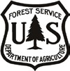
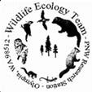
If not a current permanent (career or career conditional) employee, are you eligible to be hired under any of the following special authorities?

PERSON WITH DISABILITIES VETERANS RECRUITMENT ACT
□
□
DISABLED VETERAN W/ 30% COMPENSABLE DISABILITY VETERANS EMPLOYMENT OPPORTUNITIES ACT OF 1998 FORMER PEACE CORPS VOLUNTEER
□
□
□
PATHWAYS PROGRAM
□
OTHER:
□

Email completed form, cover letter, transcripts and resume to ayoungblood@fs.fed.us by December 21, 2018

