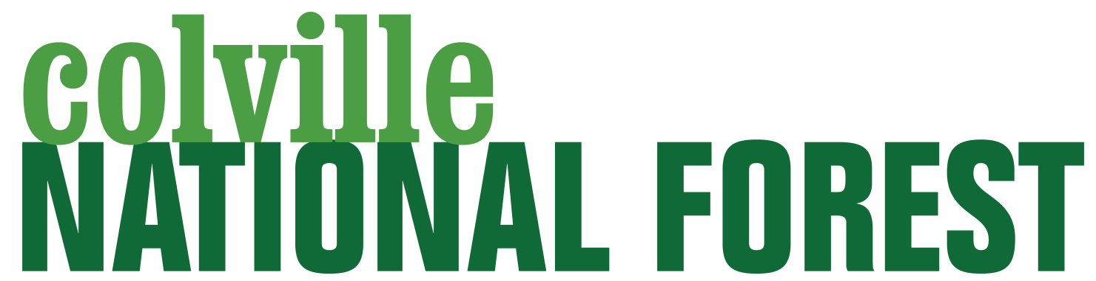

Outreach Notice

GS-0193-09, Archaeologist
Forest Supervisor's Office
Colville National Forest

Outreach Response Date: May 8, 2019
Vacancy Closing Date: [If applicable, if not delete]

Merit OCR xxx-x-x-xxx
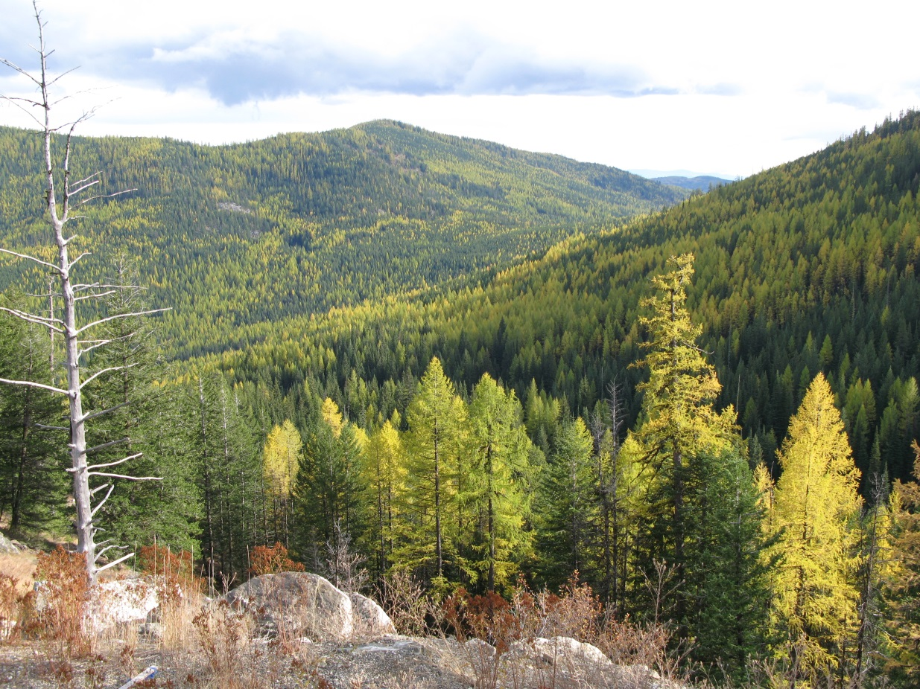
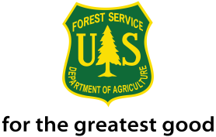
About the Position

This is a permanent, full-time position and duties include assist with hiring seasonal crews, oversight of summer seasonal crews, complete site monitoring, site updates, and DOEs with assistance of seasonal staff, complete CRI reports for large NEPA Projects, complete CRI and CRI reports for small NEPA Projects, complete DOE reports for evaluated sites, assist and/or propose/supervise Passport in Time projects, complete Section 106 reports for completed CRI, complete all forms associated with Section 106 reports, complete data entry for Heritage 2.0 NRM for sites and events (reports), compile quarterly SHPO submissions in compliance with PA, complete curation of artifacts located during project inventories, complete site record, inventory reports, and library filing and maintenance. The position will be supervised by the Heritage Program Manager/Forest Archaeologist and the duty location will be Colville, WA.

The Colville National Forest is looking for an individual interested in collaboration, building relationships, and embarking on new ways of doing business. If you enjoy innovation and teamwork, this may be the place for you!

Interested individuals should complete the attached outreach response form. This ensures that you will receive notification when the vacancy announcement is posted on www.usajobs.com.

For questions about this position, please contact:

Alicia Beat
Heritage Program Manager/Forest Archaeologist
Colville National Forest Service
765 S. Main St.
Colville, WA 99114
Telephone: 509-684-7251
Email: aliciadbeat@fs.fed.us

About the Colville National Forest

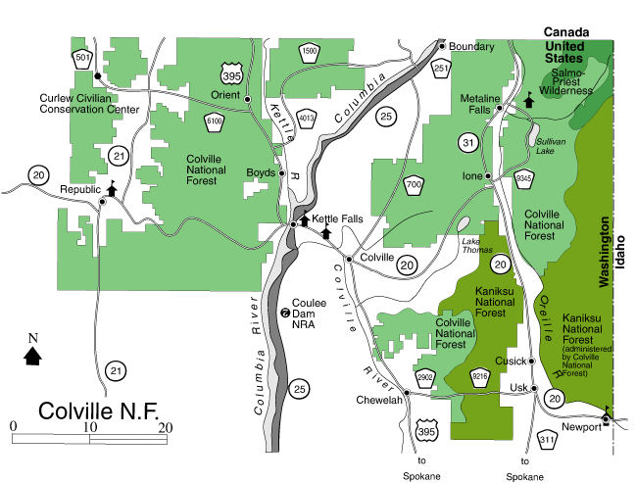

Tucked into the northeastern corner of Washington State and nestled at the foot of the northern Rocky Mountains, the Colville National Forest is an exquisite landscape of forested mountains, clear mountain streams, and fertile valleys. The 1.1 million acre forest was shaped over 10,000 years ago by Ice Age glaciers that carved three major valleys: the Columbia, Sanpoil-Curlew, and Pend Oreille River valleys. The mountains and valleys that comprise the lush northeast corner of Washington roll like waves on the high seas. Three waves of mountains run from north to south, separated by troughs of beautiful valleys. These ranges, the Okanogan, Kettle River and Selkirk are considered the eastern edge of the Okanagan highlands and the foothills of the Rocky Mountains.

The Forest has four districts supervised by three District Rangers: Three Rivers Ranger District located in Kettle Falls, Newport and Sullivan Lake Ranger Districts and the Republic Ranger District. Each unit tends to have distinctly different zones, each with its unique climate, topography, and vegetation. Each district office is located in one of the major river drainages: the Sanpoil-Curlew River Valleys, the Kettle-Colville-Columbia River Valleys, and the Pend Oreille River Valley. The Forest also provides services to the Curlew Job Corps Center located 30 miles north of Republic.

Forest topography is varied, ranging from rounded mountain slopes at low elevations to high peaks and basins above 7,300 feet in elevation. Primary access is through approximately 4,400 miles of roads and 518 miles of trails. Ecology is highly diverse ranging from ponderosa pine and Douglas fir on drier sites to western red cedar, western hemlock, western white pine and a variety of deciduous species on wetter sites. The Forest also has a significant expanse of lodgepole pine and the famously beautiful western larch. Wildlife includes a tremendous variety including whitetail and mule deer, elk, moose, bighorn sheep, mountain goats, and black bear. Rare sightings are also possible of the threatened grizzly, Canada lynx, and endangered woodland caribou. Another amazing sight is the large number of bald eagles that winter along the major rivers and nest in the vicinity.

Our lakes, rivers, and streams offer an abundance of German brown trout, rainbow trout, eastern brook trout, westslope cutthroat trout, bull trout, mountain whitefish, largemouth bass, smallmouth bass, burbot, Kokanee salmon, and yellow perch. We have groomed cross-country and snowmobile trails, many miles of backcountry non-motorized trails, over a hundred miles of single track motorcycle trails, a growing network of ATV routes, as well as opportunities for rock climbing, mountaineering, swimming, watersports, bird watching, and opportunities to find solitude in the Salmo-Priest Wilderness or several other roadless areas. No matter what your recreational interests are, you’ll probably find an opportunity to explore them further on the beautiful Colville National Forest!

About the City of Colville and the Surrounding Area

Situated in the Colville River valley about one-half mile east of the Colville River and 10 miles east of the confluence of the Kettle River and Columbia River, the community of Colville is the county seat of Stevens County, located in the northeastern corner of Washington, 40 miles south of the Canadian border and approximately 65 miles north of Spokane. Colville is a mountain town in America's forested northwest, a town with Victorian, as well as traditional modern homes, a clean looking rural town that serves primarily recreational, agricultural, and industrial interests. Colville is located at the junction of U.S. Highway 395 (north-south), which runs from Mexico to Canada through the center of Colville, forming the town's main street, and State Highway 20 (east-west), which runs from the Idaho-Washington border to the Pacific coast and Washington's San Juan Islands.

Colville sits at 1,635 feet in elevation and while being located at a high latitude (48°32”), the area enjoys four distinct, beautiful seasons with temperature ranges (in Fahrenheit) from a median low of 24.5° to a median high of 75.7°. Temperatures in the summer sometimes rise into the 90’s during daytime but cool to the 60’s after dark for pleasant sleeping. The average precipitation is approximately 17" of rain and 48" of snow with some precipitation occurring nearly every month. The average length of the growing season in and around Colville is 140 days, ranging from May to October. The sun shines most summer days and winds are gentle, averaging about 6 mph.

The population of Colville is approximately 5,000 with a larger trade area of an additional 30,000 people living in smaller communities. The major employers include Boise Cascade, Vaagen Brothers Lumber, Hearth & Home Technologies, Colmac Coil, Hewescraft Boats, Walmart, Colville School District, U.S. Forest Service, Stevens County, Providence Mount Carmel Hospital, Washington State Department of Natural Resources, City of Colville, Washington Dental, and NE Washington Rural Resources.

Colville offers five public schools, K-12, including an award winning high school and three private schools. Colville School District is also part of an innovative program to assist home schoolers with their education through a combination of activities, online work and classroom time. Colville houses a branch of Spokane Community College which offers both credit and non-credit classes.

Community health facilities include a new hospital, a 34 million dollar project, with a complete staff of physicians, surgeons and a variety of specialists. The area also has numerous dentists, two assisted care facilities, and two nursing homes.

Colville has two grocery stores plus a 24-hour Walmart Super Center, a movie theater, a drive-in movie theater, several regionally known restaurants, two full-service auto dealerships, and numerous other small businesses. If you can’t find what you’re looking for in Colville, Spokane (65 miles) and Coeur d' Alene, ID (97 miles) offer extensive shopping, restaurants, and entertainment. Spokane is also a major medical center servicing the inland northwest and offers access to a wide range of specialists and several top ranking hospitals. Spokane’s international airport is serviced by seven carriers with connections to a number of major hub airports. An airport shuttle operates between Colville and Spokane twice a day.

The Colville Chamber of Commerce’s slogan is “Discover Our Good Nature.” The community boasts a number of active civic groups, a performing arts theater in nearby Kettle Falls, an “eat local” food movement, community-supported agriculture and a community garden that has made headlines. Colville is also known for its excellent library and parks and recreation programs, including summer reading programs, swimming programs, and a full slate of summer youth programs.

Within a short drive, you’ll find a number of scenic byways, numerous golf courses, boating opportunities on large and small lakes, wildlife viewing, fishing, hunting, hiking and paddling. If winter sports are your passion, the area has abundant downhill and cross country skiing, snowmobiling, and backcountry opportunities. These opportunities abound on the Forest and neighboring state and federal lands including the Lake Roosevelt National Recreation Area and Little Pend Oreille National Wildlife Refuge. Even more adventures await in the nearby landscapes of north Idaho and southern British Columbia. There is no question about it, the Colville area is a wonderful place to live, work and play! For more information contact the Colville Chamber of Commerce at 509-684-5973 or check the website at www.colville.com.

OUTREACH RESPONSE FORM

Please respond by June 8, 2019.

If you are interested in applying for this position and want to receive updates of the position’s status, please complete the attached outreach form and send electronically to alicia.beat@usda.gov or mail to:

Colville National Forest - SO
Alicia D. Beat
765 S. Main St.
Colville, WA 99114

I am interested in the following position:

Position Title/Series/Grade: |  | GS-0193 – 09 Archaeologist
Location: | Region 6, Colville National Forest, Colville, WA

Name:
Address:
Email Address:
Phone:
If current federal employee:
Current title/series/grade:
Current agency and location:
Type of Appointment:
Permanent |  |  | Term |  |  | Temporary
If not a current permanent employee are you eligible for appointment under any of the following special authorities?

- Persons with Disabilities ____
- Former Peace Corps Volunteer ____
- Public Lands Corps Program ____
- Pathways Internship Program ____
- Recent Graduates Program ____
- Veterans Recruitment Act ____
- Disabled Veteran (30% Compensable) ____
- Veterans Employment Opportunities Act of 1988 ____

How did you hear about this outreach? ______________________________________

