BEGINNINGS

March 3

I spent the day in Seoul today, being "in-processed" by Fulbright and getting a cell phone. It's a used phone and has an account that is $10.00 monthly or so. I don't need a cell phone much but it's a safety device in a country where I really can hardly get a word of language to cross my lips and I cannot read at all easily yet. When one travels, the names assigned to bus stops seem pretty random -- such and such an elementary school for example. But I made my way home successfully via a subway + a bus route no-one had shown me. An adventure.

March 6
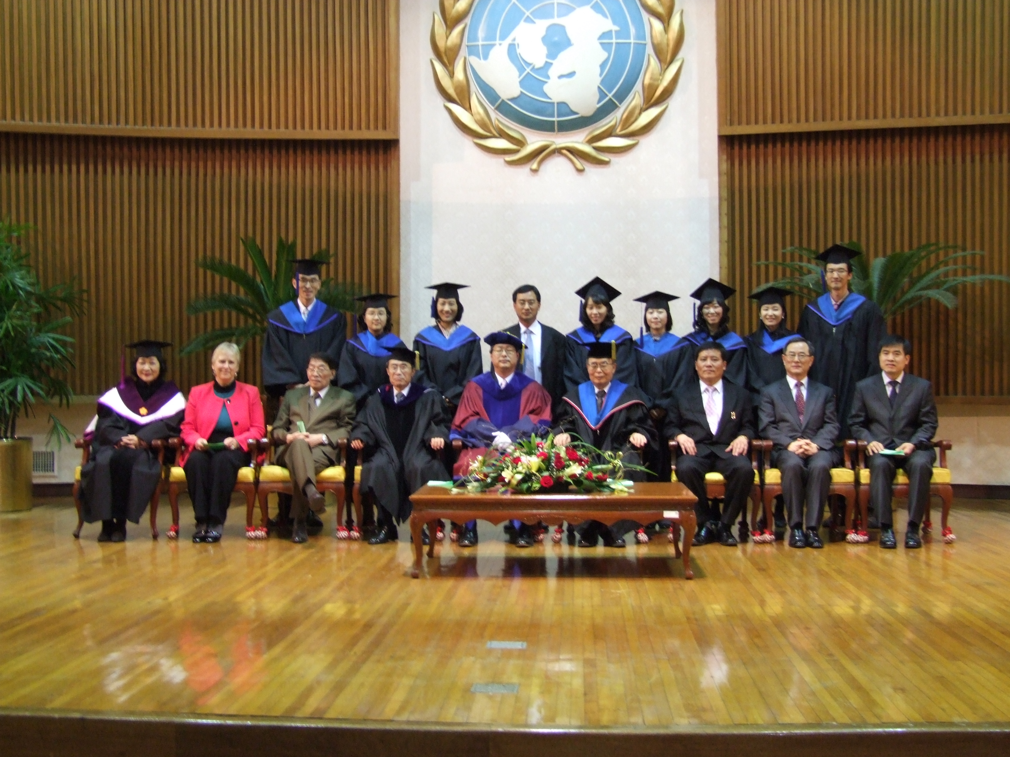
I woke up this morning to realize that I have been here 10 days. Time really does fly. I've done my first class -- 10 bubbling students and more to come next week. I may promise more fun in class and more participation than some of my older and rather more severe colleagues. Last week's formal graduation photo shows you the full array, missing only Chong Sik Lee, a distinguished Korean American scholar. I am looking forward to meeting him.

March 17
I hope that neither my old Japanese friends nor my new Korean ones would be offended by my instinct to make patterns that compare the two nations. Humans make patterns all too easily, as my Statistics co-teacher at Evergreen used to say. But like an Asian who sees deep similarities between the French and the Germans, I find I am making patterns linking the Japanese and Koreans.
A similarity --- the banking systems of these hugely important global trading companies. They have a difficult time allowing foreigners to actually use their home grown banks -- VISA on an ATM means nothing. After all there's Korean, or Japanese VISA and then there are those cards whose provenance simply cannot be ascertained. In Korea it's even the case that an ATM that "speaks" English may well not accept alien cards. And service in the banks is the same too. Take a number and wait your turn. Perhaps 40 minutes.
DIfferences -- there are many. Today's concerns the food. Not the spices, but the aesthetics. KFC and Starbucks are everywhere. Mikky D's as well. And they look similar. I'm talking about the local food. Korean food comes in lots of small dishes, reminiscent of Japanese food, but the dishes themselves are not pretty. My Fulbright confidante says -- “no, the Koreans are practical.” And that's true. Some of the serving dishes have a fine aura -- old, ceramic, blackened and on the right day sizzling with hot rice. But most are institutional china. Chopsticks are metal here, and very practically, they come with spoons.

ENDINGS

June 5
Last year, when I began talking about coming to Korea, quite a few people wondered "why Korea?" Now, in these more crisis laden times, the reasons a peace studies specialist might be here are more obvious. But today's e-mail is going to be about the mundane and not the dramatic. There will be more military tests and more diplomatic drama. Still, I am reasonably sanguine myself, and like most people in South Korea I just go about my daily life.

When I first arrived, this country was brown and grey -- frozen grasses, trees with no leaves and even the evergreen shrubs had a burned quality to them. Huge numbers of small patches of ground looked desolate and abandoned. Bare earth and rocks. Now four months later it's all changed. Those bare patches of ground turned out to be dozens and dozens of small vegetable patches, and I've commented several times already on Korean passions for flowers. Now we're through the peonies and into roses -- banks and banks of red climbing roses.

I gave a lecture this week to students in hotel management entitled Touring Seoul with the Eyes of a Peace-maker. The current national agenda is to sell Korea as a shoppers paradise. It is in the sense that there's lots to buy and it's cheap. But they are missing the distinctiveness of Korean shopping -- those riverside markets and arcades I talked about. Local retail everywhere. They want to send us to a vast underground Mall. It's vast alright but underground, and the vastness cannot be seen from any given passageway. The tourguides are also missing the distinctiveness of Korean scenery, the farming for instance. Rice paddies are everywhere -- even between the city and the airport. At the industrial scale, it's remarkable that so much farming is still happening within the confines of city life. At the local scale it's humane and quite lovely and incredibly tidy.

June 19
I am sure I will be going back to Korea sometime, perhaps sooner rather than later. They have invited me to consider being an "international scholar" and I have realized that there are things I could teach students at GIP about research and analysis including ways to approach data unclouded by emotions, while connected to rigorous scholarly traditions. More important, my own work stands to gain a lot from doing more here.

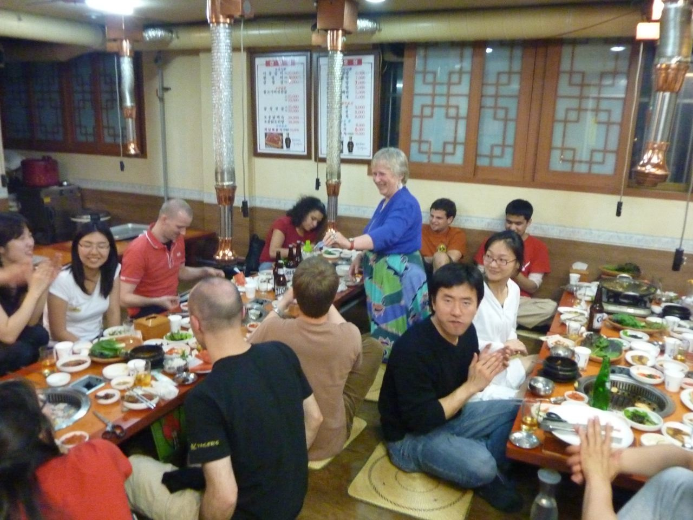
In Seoul this week Rob and I spent a lovely four days ensconced in the tiny Hanok, a traditional guest house I have come to love. Small pond outside the back door to the room. Table and chairs right there and evening light to sit by. (+ bugs, not so nice the second night). We wandered art museums and temples. We bought shiny shoes for the UK kids and glittering jewelry for me. We went on a boat ride on the Han river as a farewell to a beautiful body of water. And I gave a pretty successful talk at Fulbright headquarters about the research. Then back to GIP to pack and clean up the details of life -- grades for the students, 50 more questionnaires to process, one last dinner with the wonderful Chong-Sik Lee and packing 4 months of life back into the suitcases it arrived in.

