VISTAS Example Images

VELMA. Projected changes in land use and climate are widely expected to alter watershed processes. However, the extent of these changes is difficult to predict because complex interactions among affected hydrological and biogeochemical processes will likely play out over many decades and spatial scales. VELMA and VISTAS will be applied in tandem to analyze and visualize current and future impacts of land use and climate on ecosystem structure and function in the 64 km² HJA watershed. For example, this framework is being used to examine the effects of climate change for best case, worst case and middle-of-the-road climate change scenarios. For one scenario, simulation results suggest that the effects of warmer and wetter winters combined with drier and hotter summers will result in lower winter snow accumulation, earlier spring snowmelt, higher winter streamflow, and lower summer streamflow and soil moisture. VELMA also indicates that warmer air temperatures will enhance soil microbial activity and lengthen the growing season. In turn, these changes will lead to higher plant and soil carbon accumulation and increased carbon and nitrogen losses from the terrestrial system to the stream and atmosphere. A basin-scale, multi-century VELMA simulation of these effects can generate hundreds of gigabytes of model output. Without advanced visualization tools such as VISTAS, these data would be extremely difficult to interpret scientifically, or to communicate to land managers, policy makers and community stakeholders.
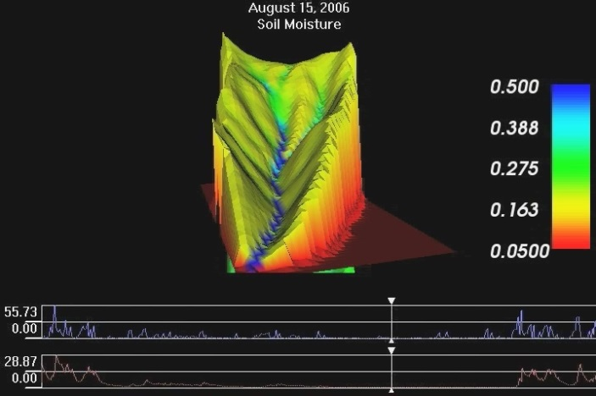 | 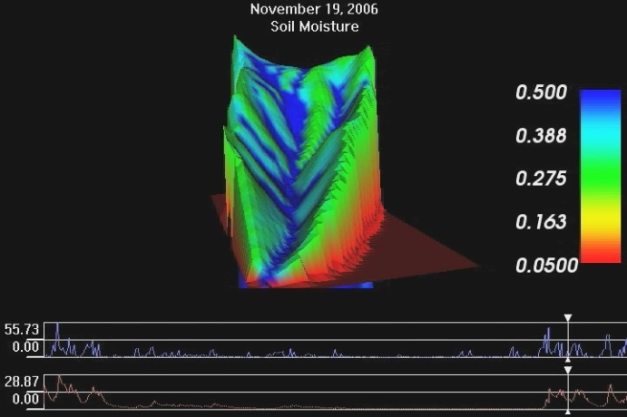
August 19, 2006 | November 19, 2006

Figure 1: VISTAS visualizations of VELMA (Visualizing Ecosystems for Land Management Assessments) soil moisture simulations for the HJA LTER Watershed 1 (WS01). These show soil moisture in the surface soil layer (0-50 cm). The line graphs at the bottom of each image show daily total precipitation and stream discharge during 2006. The soil moisture legend is in terms of volume of water/volume of soil (in general, a value of 0.5 reflects saturated conditions). Courtesy Bob McKane, EPA,Corvallis, OR. See also, for example, the following link which discusses VELMA’s capabilities for simulating effects of land use and climate change on ecosystems: http://abstractsearch.agu.org/meetings/2012/FM/sections/H/sessions/H54A/abstracts/H54A-02.html).

VISTAS takes as input VELMA output files (see data description below), and drapes those on top of digital elevation maps, as per precise lat-long information provided by the scientist seeking the visualization. VELMA output files contain data describing how biophysical variables (such as soil moisture and plant growth) change over the landscape during a series of days. VISTAS also takes as input VELMA input files used to generate that simulation, such as daily average temperature and precipitation. VISTAS then creates still images or animations that show how VELMA output changes over time. The user can view more than one variable at a time (in separate windows), and can vary the view of the 3D image. He or she can also elect to exaggerate the topography, and select the color scheme for viewing.

VELMA is a spatially-distributed (grid-based), eco-hydrological model that simulates a number of variables pertaining to soil and land cover. Its output consists of several raster files that each include variable, soil layer, and unit of time (typically in days). Each raster in the dataset is represented as an ArcInfo ASCII grid. The filename of each grid file indicates its place in the later dataset (variable, day, etc.) The collection of grid files can be thought of as a 5-dimensional dataset (x, y, time, run, soil layer).

Size of the raster files can vary greatly, and is a factor of grid resolution (e.g., 30 meters), number of variables, layers, runs, and days. Typical datasets for which VISTAS is currently visualizing range from 100 MB, with grids about 54 KB to 5.9 GB, with each grid about 1.3 MB. VELMA developers expect size of VELMA files to grow considerably over the next few years, as they increase the size of the geographical area modeled, and the resolution. In terms of a physical landscape, such as the HJA, the relationship between grid size and output file size is not quite linear. This is because VELMA output files are in ASCII and the VISTAS file is binary; filesize depends on the precision of the floating point numbers. In a binary file, the precision is usually fixed so that it contains floats, each value requires 4 bytes. In the ASCII file, however, the size of each number is determined by how many characters are taken to represent the value. For VELMA, this is usually capped at 12 characters (using scientific notation to maintain that cap) so values range from 1 to 12 bytes. If we assume each value takes the full 12 bytes (even though the no data value -9999.0 takes 7 bytes) then the file size calculation (per variable, run, layer, day) is 70,000 (number of pixels) * 12 = 840,000 bytes or 820KB (plus another few kilobytes or so of header data), or for the whole data set, 820KB * variables * runs * layers * days. For example, if a VELMA run uses 30-m pixels for the HJA and there are 70,000 of those pixels, that translates as follows to a VISTAS file, as follows:

