Visualizing Terrestrial & Aquatic Systems in 3D
Cushing et al
IEEE VisWeek 2014 Poster Submission
Preliminary Video Supplement
This supplement to our VisWeek submission consists of 2 preliminary videos produced by scientists using VISTAS software:
- Hydrological-biochemical Processes, Winant Slough Salt Marsh, Oregon Coast, USA, from data output by R. McKane using VELMA model (Visualizing Ecosystems for
Land Management Assessments). Video demonstrates denitrification process; The slough (salt marsh) provides an ecosystem service by decreasing the flow of nitrate, a water pollutant, from upland areas to the estuary.
- Alternative Land Use Futures Scenario - Central Oregon Alternative Futures. This project focuses on better understanding how biophysical systems, management actions and socio-economic influences interact to affect sustainability in fire-proof landscapes under climate change, and aims to improve wildland fire policies in the U.S. The video shows a side by side fly-through animation of Left: vegetative cover (giant trees to seedling, shrub, meadow, barren, developed), and Right: land use (homeowner, tribal, private or public industrial, state or federal).
Visualizing Ecosystems for Land Management Assessments
(VELMA)
Hydrological-Biogeochemical Processes
Winant Slough Salt Marsh, Oregon Coast, USA

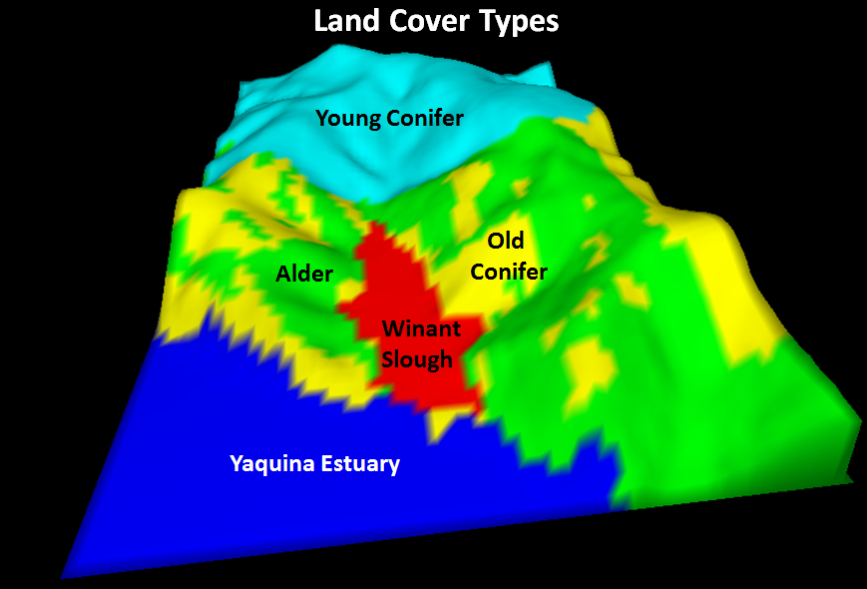

VELMA modelers generated and used 4 VISTAS videos in stakeholder presentations: symbiotic nitrogen fixation, NO3, soil water, and denitrification.
Modelers (McKane et al) used the videos to demonstrate to themselves that the model successfully quantified and dynamically mapped eco-hydrological processes controlling upland nitrogen inputs to the salt marsh.
They also report that process-level interactions “pop out” in 3D, and help identify hot spots and moments.
Hydrological-Biogeochemical Processes - Winant Slough Salt Marsh, Oregon Coast, USA
The slough (salt marsh) provides an ecosystem service by decreasing the flow of nitrate, a water pollutant, from upland areas to the estuary.
In the study watershed, nitrate is produced in abundance under Red alder (Alnus rubra), a common tree species in PNW coastal forests that fixes (converts) atmospheric nitrogen into organic forms.
Some of the fixed nitrogen is subsequently transformed to nitrate by soil microbes. Nitrate is readily transported in soil runoff and contributes to eutrophication of streams and estuaries.
However, denitrifying microbes that live in wet soils and sediments are able to convert nitrate to nitrogen gas, thereby providing an ecosystem service with respect to water quality protection.

3D Visualization Capability for ENVISION
Envision was created to conduct research about the nature and properties of coupled human and natural environmental systems in the context of climate change.
The approach employs scenarios, data and evaluative models produced by past research (Harmon, Gregory, Bolte), and builds on prior work in agent-based modeling.
Central to Envision are the 3-way interactions of
- Agents, who have decision making authority over parcels of land,
- Landscape which is changed as these decisions are made, and
- Policies that guide and constrain decisions.
ENVISION currently produces 2D maps, but wants 3D animations to help stakeholders better understand alternative futures. Enter VISTAS….
Alternative Land Use Scenarios -- Central Oregon Alternative Futures
This project focuses on better understanding how biophysical systems, management actions and socio-economic influences interact to affect sustainability in fire-proof landscapes under climate change, and aims to improve wildland fire policies in the U.S.
The following video shows a side by side fly-through “camera-position-coordinated” fly-through at one specific point in time of two different attributes.
- Left: vegetative cover (giant trees to seedling, shrub, meadow, barren, developed)
- Right: land use (homeowner, tribal, private or public industrial, state or federal).
The video was produced by ENVISTAS – the VISTAS visualization engine embedded into ENVISION.

